**Bike Sharing Hourly Counts Information to Foresee Near Future Trend**

**1. Business understanding:**

* 1. The objectives of the business

This study is to identify the near future trend of bike sharing. Used Knowledge Discovery in Databases (KDD) methods and given the foreseeable trend, the business could understand the situation of bike sharing better, so that they would make good investment and adjustment to the bike sharing strategies and systems.

* 1. The situation

As known, bike sharing is getting more and more popular in recent years around the globe. There are massive of opportunities for bike sharing business. On the other hand, cycling could potentially reduce heavy burdens on public transports and be convenient for certain groups of people, and beyond. Bike sharing has peak and low hours and usages as well, such as morning rush hours, after work hours. Although the users of bike sharing are increasing and there are more and more opportunities for business, it would be better if the business could serve them even much better by inputting efforts on providing more supports, and attracting even more users. In addition, there must be popping up many other rivals in bike sharing market to defeat each other. Hence, it is good time to review the situation to seize the market shares.

* 1. Data mining objectives

In this data mining objectives, it is not going to find out that bike sharing could reduce traffic congestion. Ricci (2015) argued that there is no evidence on bike sharing reducing traffic congestion and any other environmental issues. Hence, I will not look for whether bike sharing affects other issues.

Also, the raw data in this study doesn’t contain the distance information, because users may consider to use the system based on short distance. Matrai and Toth (2016) indicated that bike sharing is only for the purpose of short distance trip, occasional travel, and it doesn’t provide alternatives for long distance commuters.

Instead, the objectives of this data mining are to determine what main fields are affecting bike sharing itself. O’Brien et al. (2014) suggested that differences between weekday and weekend usage are apparent, and peak usages at different parts of the day depend on the docking station, academic and workplace locations.

In addition, to see if environmental conditions are affecting bike sharing, such as weather condition, wind speed, humidity. Based on the data that come out with the prediction information, the business could make improvement to the user experience and to satisfy users’ enjoyment in using the services. Furthermore, it could potentially increase various groups of people in wilder range to use bike sharing with different purposes.

* 1. Project plan

The following is the relevant proposed time frame for conducting the project using BDAS (*Figure 1a*). I also capture screen shot for the Gantt chart planner for greater details (Figure 1b) – ***please do refer to Project Plan Gantt chart attached (Project_plan.xlsx) in the zip file for greater details, because it is dynamic chart rather than static one below*.** The entire plan has total 20 days to complete. I break down the plan into two separated streams: the plan start and duration; the actual start and duration. Percent complete is the indicator comes along the way to help me monitor my progress.

|  |  |
| --- | --- |
| **Timeline** | **Item Progression** |
| 23/09/2018 – 25/09/2018 | Business understanding; Data understanding |
| 26/09/2018 – 26/09/2018 | Data preparation |
| 27/09/2018 – 28/09/2018 | Data transformation |
| 29/09/2018 – 30/09/2018 | Data-mining method(s) selection |
| 01/10/2018 – 01/10/2018 | Data-mining algorithm(s) selection |
| 02/10/2018 – 05/10/2018 | Data Mining |
| 06/10/2018 – 08/10/2018 | Interpretation |
| 09/10/2018 – 09/10/2018 | Feedback to the model |
| 10/10/2018 – 10/10/2018 | Refinement |
| 11/10/2018 – 11/10/2018 | Action |
| 12/10/2018 (DUE) | Submission |

*Figure 1: Brief Project Plan Extracted from Project_plan.xlsx*

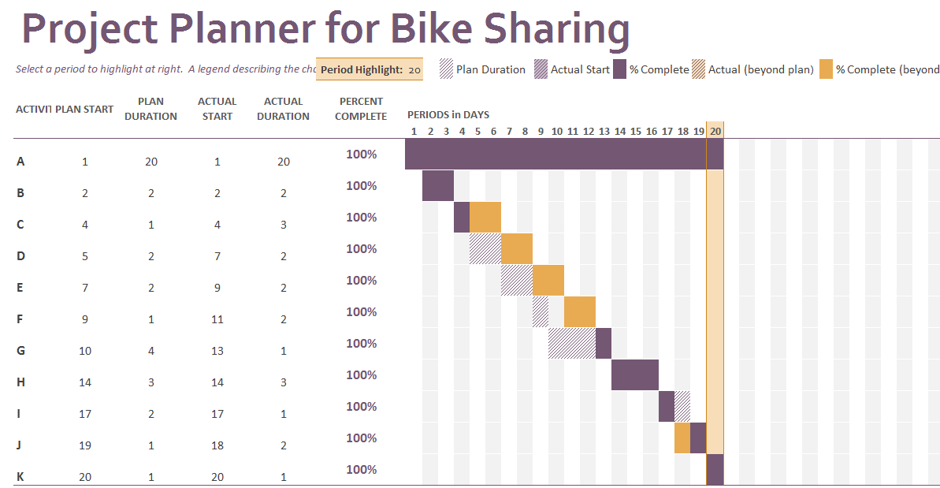

*Figure 1b: Project Plan Gantt Chart*

**2. Data understanding:**

2.1 The initial data

The data are collected by Fanaee-T and Gama (2013), who was one of the researchers under the Capital Bike Sharing System in Washington D.C., USA. The data have a variety of formats, which are publicly available by clicking [*HERE*](http://capitalbikeshare.com/system-data). For the purpose of this project and the software I use, CSV data format would be the best option, because the following software I use would help organize the data. If I use Excel instead, it would probably have incompatible issues with other software as we know that the Excel application itself incorporating many features.

The data come with two separate collection sets: one is bike sharing counts based on daily basis; the other one is bike sharing counts based on hourly basis. I try to sum up all the hours into a day and it is exactly the same as the daily data. In addition, hourly data will be much more in details rather than the daily one. Hence, I choose the hourly basis for the project.

2.2 About the data

The data are collected within two-year historical log corresponding to years 2011 to 2012 from Capital Bike Sharing System in Washington D.C., USA. Also, data contain weather conditions, precipitation, day of week, season, hour of the day, etc.

Most importantly, it has the counts of users in every single hour per day. There are total 17379 hours. A glance at the CSV file from top to down, there is no missing values spotted. As known, CSV contains the raw data with comma to separate themselves. It doesn’t have powerful feature as compared to Excel. The good thing is that CSV file can be associated and compatible with many different free software and tools. Hence, conclusion of the existing data are good to go for further processes.

2.3 Explore the data

The data file is in CSV format, I then will duplicate a new one CSV data file as a back-up file in case the unexpected issues that damage my source file. Now, I am going to use the combination of software to manipulate the data. To begin with, I need to create a new remote repository so that I could synchronize all my local work to the remote repository. Logon to my GitHub account, create a new repository and type in the following information (*Figure 2*). Click Create repositoryto complete.

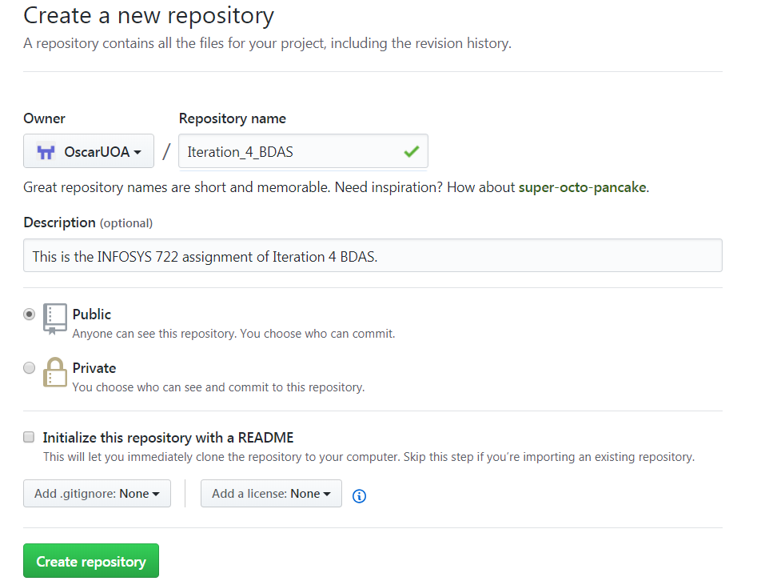

*Figure 2: Create New Online Repository in GitHub*

Then, I create a local repository that contains all my work for this study of Iteration 4 BDAS*.* Start git command prompt, and type in the followings to initialize the folder, add the source files, commit and put first comment (*Figure 3*) and click *Enter* to add the work into remote repository. For the first time to do so, a prompt will ask for username and password to authenticate the login. The GitHub now should have all the files that are the same as my local.

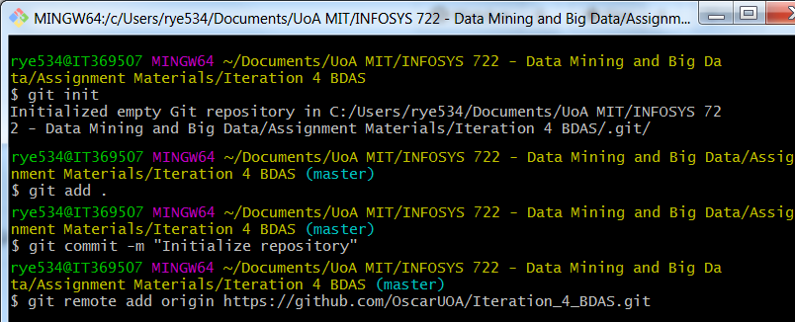

*Figure 3: git Initialize the Repository and Add Source Files remotely*

Next, start *AWS* virtual machine and login to it by using PuTTY – *this should be done in the lab and I am not going to repeat the installation steps here.* Type in the following commands to clone the remote repository to my virtual machine (*Figure 4*). I can see the folder Iteration_4_BDAS that is cloned successfully.

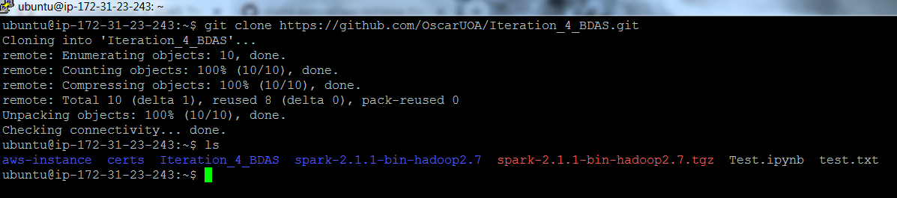

*Figure 4: Clone the Repository into the AWS Virtual Machine*

Now, all the folder structures and synchronization work have been done and I can start the real work. Type jupyter notebook and click *Enter,* I copy the link (- *note to change the IP address that indicates in my AWS instance*), paste into my browser and locate the workspace of juptyer. Click *New* and select Python 3 to create a new file so that I could put my scripts on it. First of all, I change the file name to Explore the entire data – *please note that all the script files will be put under different folders accordingly to the section I work on.*

Run the following scripts (Figure 5), and I got total 17379 records which is exactly same as the raw CSV data file. Hence, I can confirm that the CSV file in repository is successfully and correctly placed in GitHub.

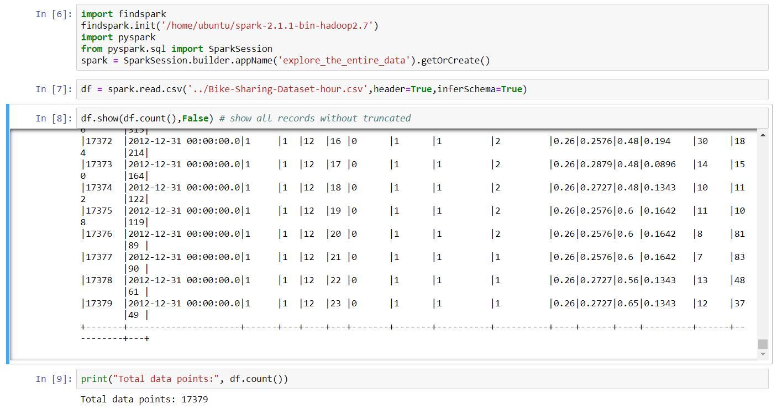

*Figure 5: Retrieve and Display Whole Dataset*

We take a look at the *Figure 5* – *scroll the dataset from top to down*. It is noticed that the casual, registered and cnt numbers are getting bigger when the hr lines during 8am to 19pm, and the cnt is the total of casual plus registered. Also, workingday falls on 1 (- working days). If it is not a working day but it is holiday, the counts drop sharply. This is interesting fact that the bike sharing is potentially suit for those people are running in rush hours. However, it needs to have further assessment to confirm this.

In order to understand the data more, I then get the type of the dataset (*Figure 6*). Most of them are type of integers except dteday that is timestamp, and temp, atemp, hum and windspeed are doubles. Values are allowed to be nullable.

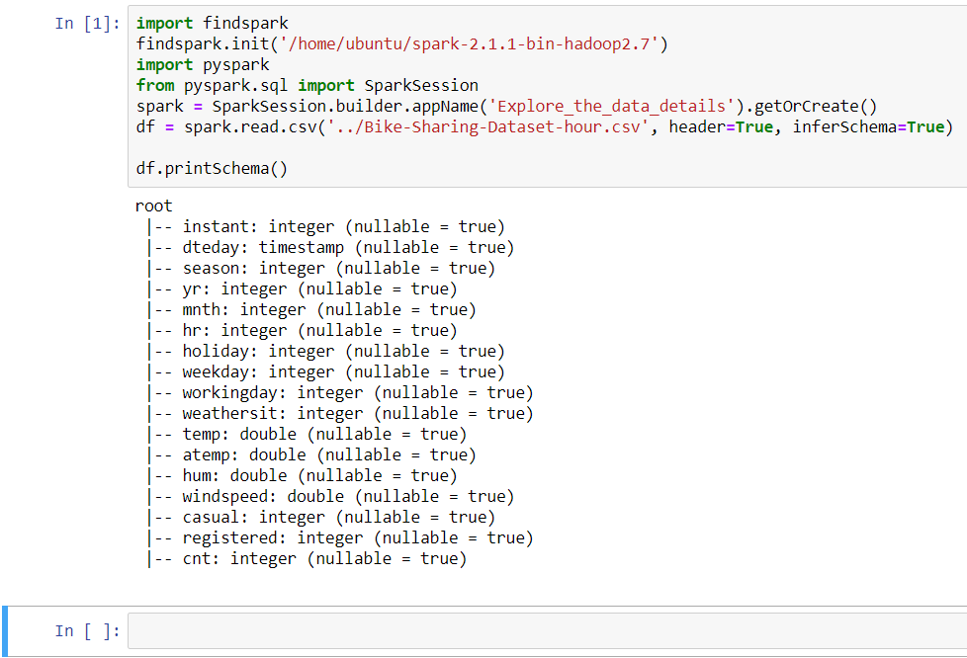

*Figure 6: Check Data Type*

I then summarize the dataset as follows (*Figure 7*):

|  |  |
| --- | --- |
| **Fields** | **Explanation** |
| instant | Record index |
| dteday | Date range from 1st Jan 2011 to 31st Dec 2012 |
| season | 1, 2, 3 and 4 that represent spring, summer, fall and winter respectively |
| yr | 0 is 2011, 1 is 2011 |
| mnth | 1 to 12, where 1 is Jan, 2 is Feb, 3 is Mar, etc. |
| hr | 0 to 23 in 24-hour format, where 0 is midnight, 1 is 1 am, 2 is 2 am, etc. |
| holiday | 1 and 0, which represent that 1 is holiday and 0 is not holiday |
| weekday | It starts with 0 that represents Sunday, 1 that represents Monday, 2 that represents Tuesday, etc. |
| workingday | It has 1 that is working day and 0 that is not working day |
| weathersit | 1 is clear and sunny, 2 is mist and cloudy, 3 is light snow and light rain, 4 is heavy rain, ice pallets, thunderstorm and severe weather |
| temp | Normalized temperature in Celsius. The values are divided to 41 (max) |
| atemp | Normalized feeling temperature in Celsius. The values are divided to 50 (max) |
| hum | Normalized humidity. The values are divided to 100 (max) |
| windspeed | Normalized wind speed. The values are divided to 67 (max) |
| casual | The count of casual users |
| registered | The count of registered users |
| cnt | The count of total rental bikes including both casual and registered |

*Figure 7: The Data Fields Explanation*

I code the following for cnt and build the histogram as shown below (*Figure 8*). It is not symmetric one but right skewed.

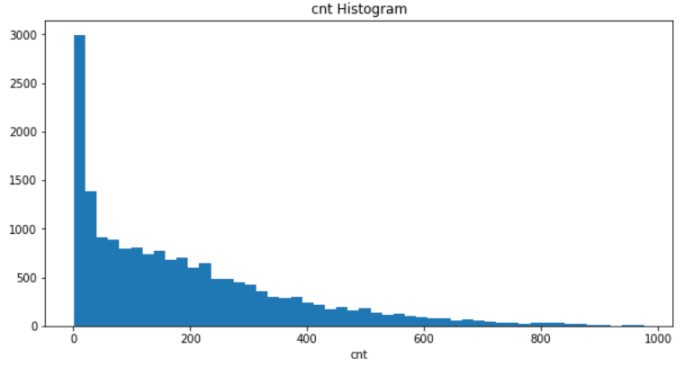

*Figure 8: cnt Skewed Right Histogram*

Plot the instant against cnt, I got results below (*Figure 9*). It indicates that the cnt is increasing from left to right. So, I could expect the growth of bike sharing is stably going up with a seasonal effect, because instant also represents the time frame of 2011 to 2012. However, there are a number of concaves. I couldn’t tell from here, I will analyze deeper with different aspects of columns to check the reason behind.

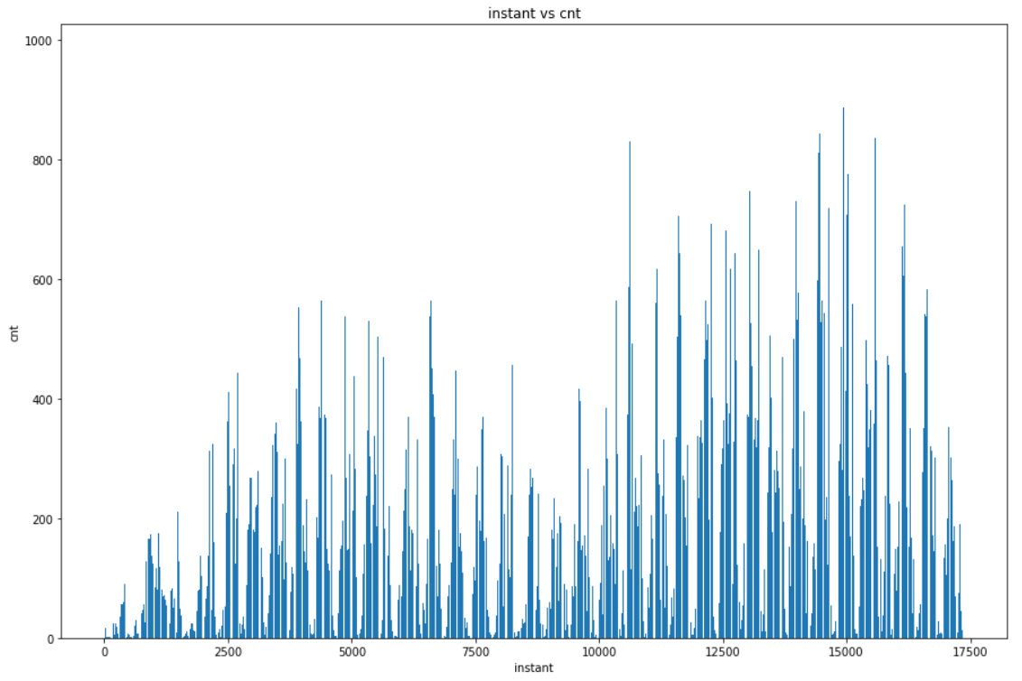

*Figure 9: The Bar Chart of instant vs cnt*

As known, the cnt is the sum of casual and registered. Hence, I put casual and registered counts as the total cnt counts across the entire duration (*Figure 10*). From the graph, it illustrates that the main portions towards the total cnt is always the registered in green color. Casual in blue color occupies small amount and it also tells that this group of users is not certain.

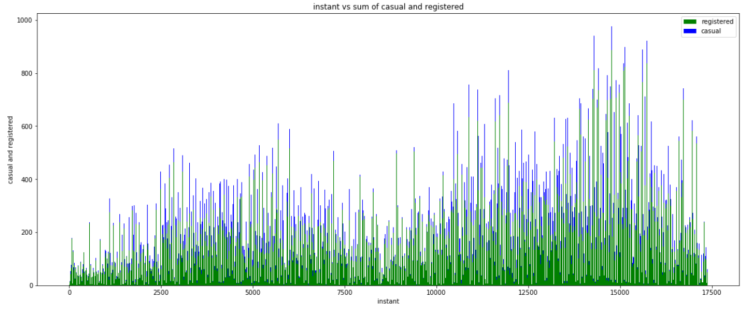

*Figure 10: Counts of casual and registered against cnt*

I then plot the very first day counts as follows (*Figure 11*). It indicates that the casual is still one of the uncertainties towards the total counts. The registered is closely aligning with cnt as we know it is the main portion to cnt.

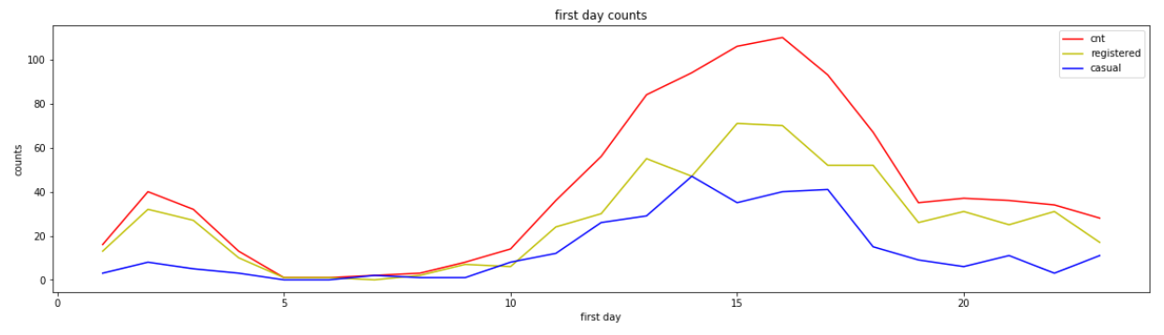

*Figure 11: First Day Counts of casual, registered and cnt*

I try the weather issues and plot them together to compare with the cnt below (*Figure 12*). The interesting thing here is that when temp and windspeed go up around the afternoon hours, the total cnt goes up. However, the cnt goes down after 16pm, temp and windspeed still remain about the same level. For hum, I couldn’t see more details from here, because it doesn’t change much.

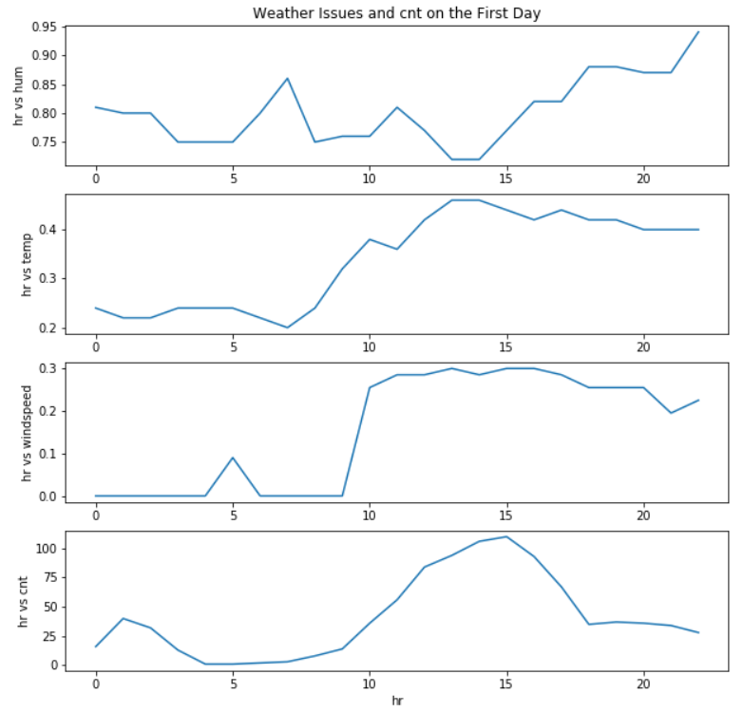

*Figure 12: First Day Weather Issues against cnt*

The weathersit seems to be involved with the cnt, because the more the cnt is, the less the weathersit is (*Figure 13*). This is reasonable as we know that weathersit represents the weather condition. In a very good day, there will be more people using the bike. Otherwise, there will be less in cnt.

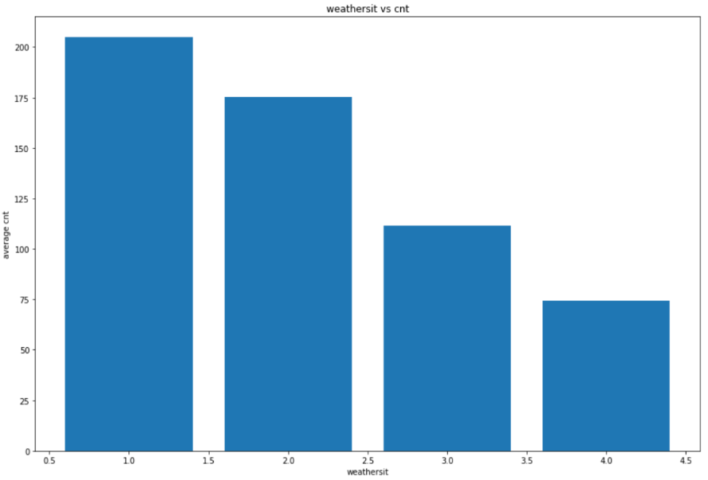

*Figure 13: weathersit against cnt*

2.4 The data quality

In data quality step, I am going to check if there is any null or empty values of my dataset. I use hr as an example to show how I am going to code to count the nullor empty values (*Figure 14*) – *please change the variable accordingly to check others.* As a result, 0 return which means there is no nullor empty values.

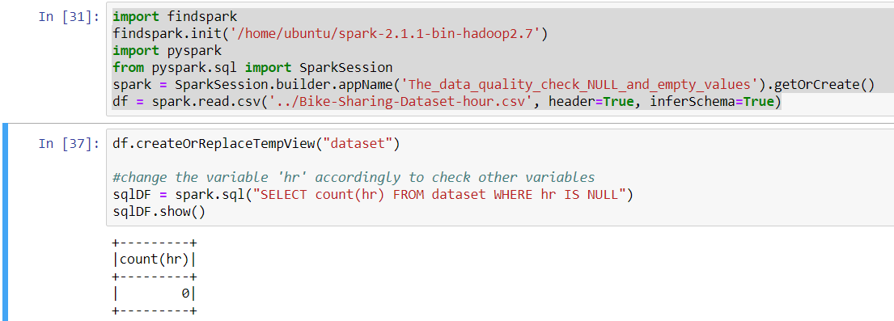

*Figure 14: Count Column with Null or Empty Values*

However, I realize that 17379 is not the total amount of hours in two years (2011-2012). 2011 is a normal year, whereas 2012 is a leap year. So, that will be total 731 (365 plus 366) days and 17544 hours instead of 17379 hours.

Now, I am going to count the hour of 0, 1, 2 till 23 one by one and check if it really misses some hours in between. Execute the script, and I have following results in hr of 0 (*Figure 15*). I can see the total count is 726, which indicates that there is missing values of hour 0. Because the total days should be 731. Moreover, I check the rest of the hours from 1 to 23 and find out there are missing values as well.

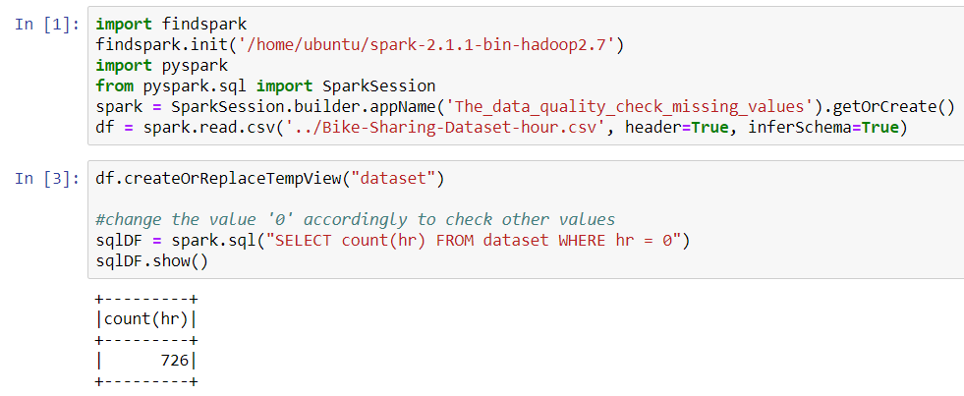

*Figure 15: Check Missing Values in hr*

Finally, I use different Python libraries to query the entire raw data from top to down again. It seems to be intact. In addition, all data are numeric without any strings or special characters or unknown formats – *I will perform the validation to confirm if all data are numeric in data clean step*. One of the columns should be in date-time format which is the dteday. Other than that, data quality is good for further processes.

**3. Data Preparation:**

3.1 Select the data

I then continue to use a series of tools to complete the task. Those tools include GitHub, AWS (EC2/AMI), Jupyter, PySpark and Spark. Prior to this iteration, I have already installed them and in the previous steps I have been using some of them.

My steps here are to clean, construct, integrate and format the data. After finish the steps, then I will continue to pull out the processed new data to do the statistics check. Visualize the data in Jupyter workspace again, which will give a brighter view for me to analyze the full complete data clearer.

At the end, I will use Jupyter workspace and further the data mining processes. Now, I am going to use Jupyter to complete the data preparation steps. The data selected for this study is the CSV raw data file.

As I have imported the data into GitHub in step 2.3 and synchronized it to my AWS virtual machine, I will then check the type of the data if their format has been established correctly during the importing and synchronizing processes.I may have done this step earlier, however, this time I will retrieve more details toconfirm and show all the data types and their specific amount of rows (*Figure 16*). I can see that the data types are not changed even though I’ve done tests on the CSV, which is confirmed that the data processing won’t change the original file. The types are still integer for most of the fields, timestamp for dteday, and double for temp, atemp, hum and windspeed. They are allowed null values inputting. I randomly print one of the rows and check, which are all good.

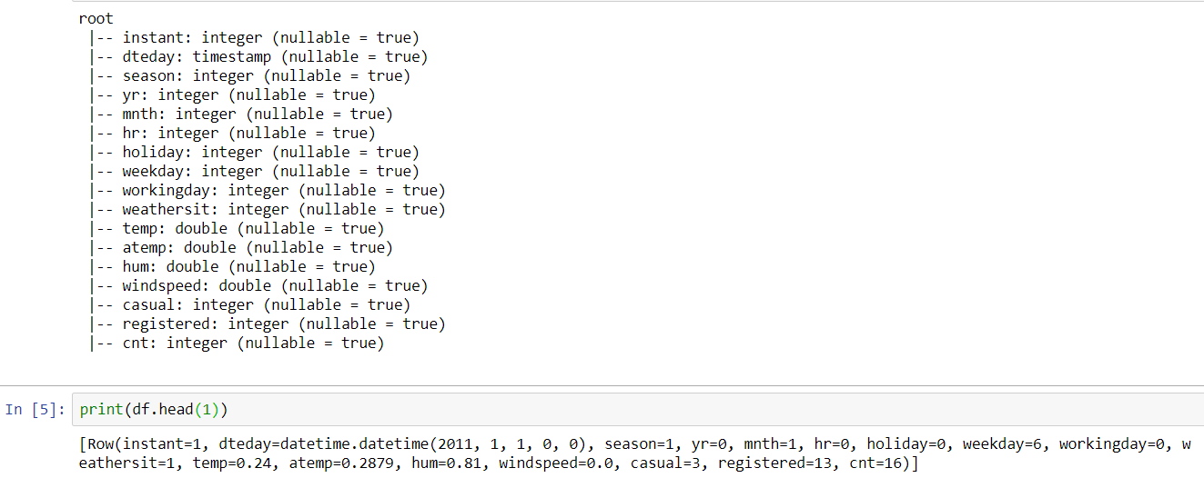

*Figure 16: Inspect the Data Types*

3.2 Clean the data

In this step, I am going to check the variables and clean all the empty or null value if there is any – *I’ve checked on 2.4 and found there is not any empty or null value*. In addition, I will check if the values and numbers of the fields are correct. For example, check if any column has negative numbers (*Figure 17*). Return 0, which means there is no negative numbers encountered.

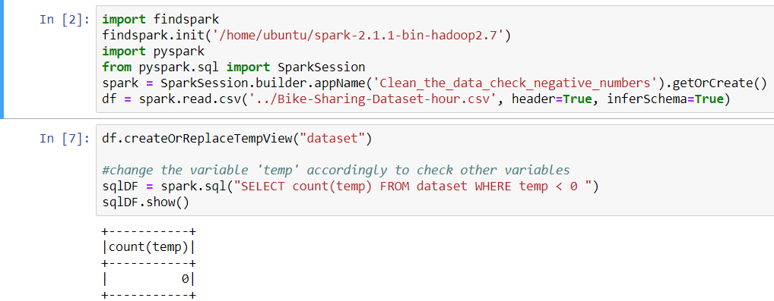

*Figure 17: Check Negative Numbers*

Then I will check if hr column has more than 23 – *hour starts at 0 and ends at 23*, if season has more than 4, and if mnth has more than 12 (*Figure 18*). Return 0, which means the hr has no more than 23 hours and result is correct.

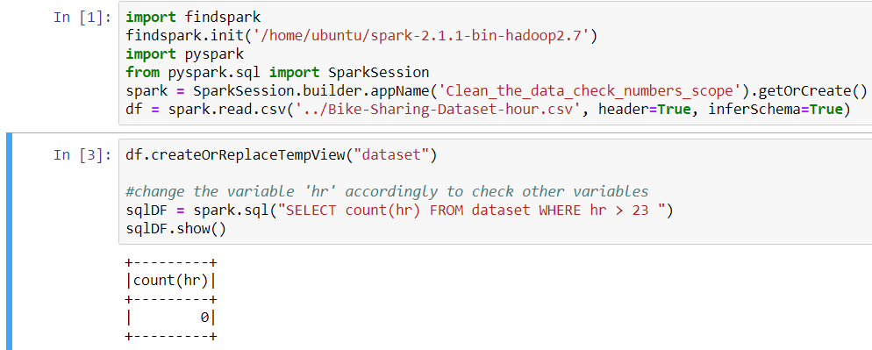

*Figure 18: Check Scope of Numbers.*

In addition, sum the total casual 620017 and registered 2672662 numbers, which should be equal to the summation of the total cnt numbers 3292679 (*Figure 19*)*.*

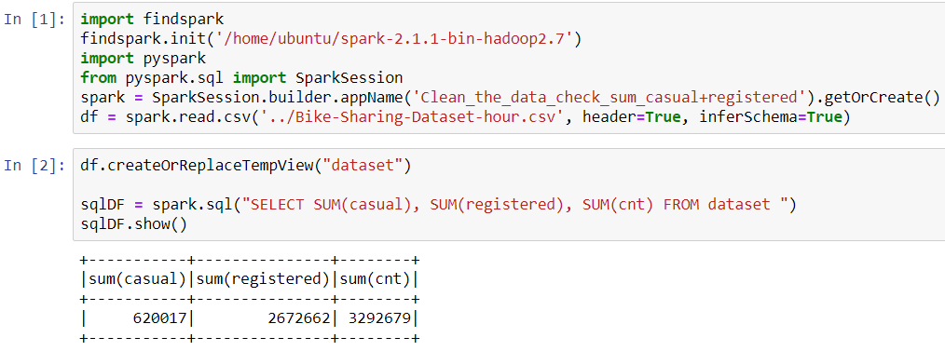

*Figure 19: Summation of casual, registered and cnt*

Secondly, I will query out all the NULL values or characters values that are not supposed to be existed in my data set. I use hr as an example as follows (*Figure 20*). As a result, there isn’t any invalid data. Continuously, I try other fields and find out there isn’t any invalid data either.

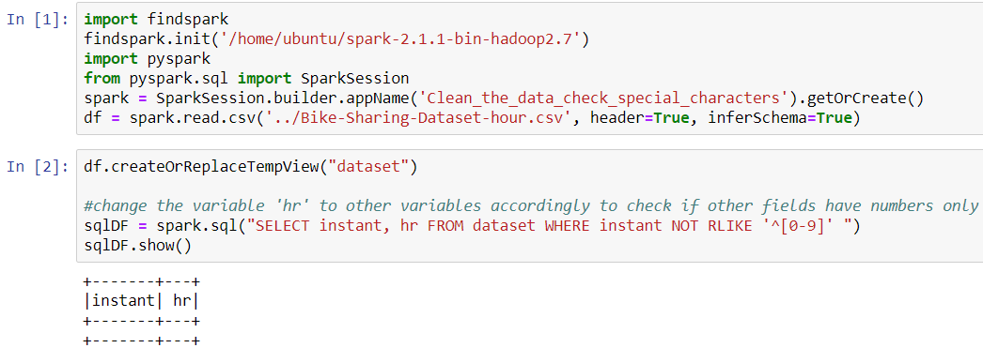

*Figure 20: Validate Values of hr Field*

Last but not least, the date format is a little different from other fields. So, I change my script to validate the dteday fields below (*Figure 21*). I try to get dteday values not with the format of ‘2011-%-%’ and ‘2012-%-%’. If there is return results, it means the value is wrong. However, there is no return results and dteday field and values are eligible.

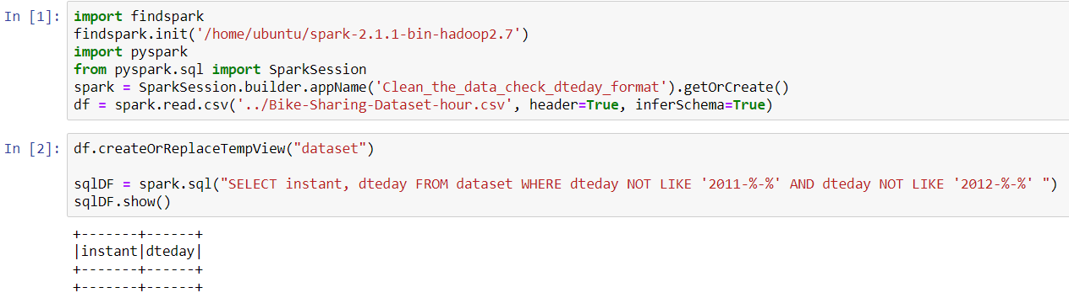

*Figure 21: Validate Values of dteday Field*

3.3 Construct the data

As in previous step 2, I have mentioned there are 165 hours missing because total hours are 17544 instead of 17379. So, I will add back those 165 (17544 – 17379 = 165) hours into my two years data set.

First of all, I divide this adding missing data process into monthly basis, which mean that there are 24 months in total and 24 adding processes. So, I will demonstrate how to add missing data in the first month that is January 2011 here. Then the adding missing data for rest of months, I will just put all the scripts I create under Jupyter folder Construct_the_data*.* Hence, it should be able to add all missing data by simulating the first month to create other 23 months missing data, because I don’t want to occupy too much space in this report by repeating the same processes.

To begin with, I use scripts to get all the average values of fields in temp, atemp, hum, windspeed, casual, registered and cnt (*Figure 22*). I will use these average values by inserting them back to the missing values later.

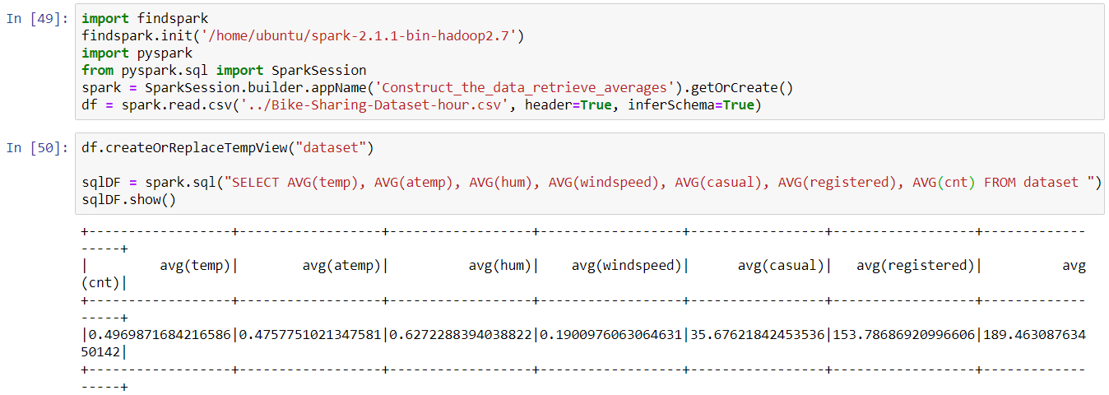

*Figure 22: Average Values of Several Fields*

Then in Jupyter, I import spark and pyspark libraries to connect to the CSV file (*Figure 23*).

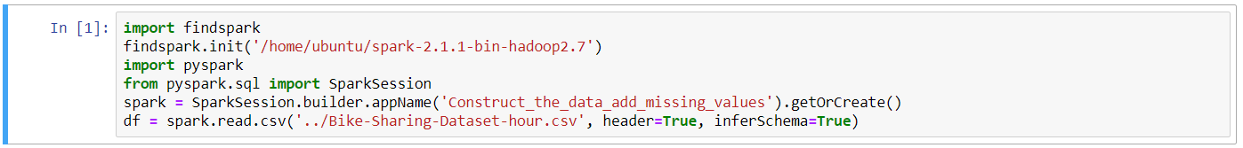

*Figure 23: Connect CSV File*

Next, I make a query to retrieve the results, define all the variables and put the results into the variables (*Figure 24*).

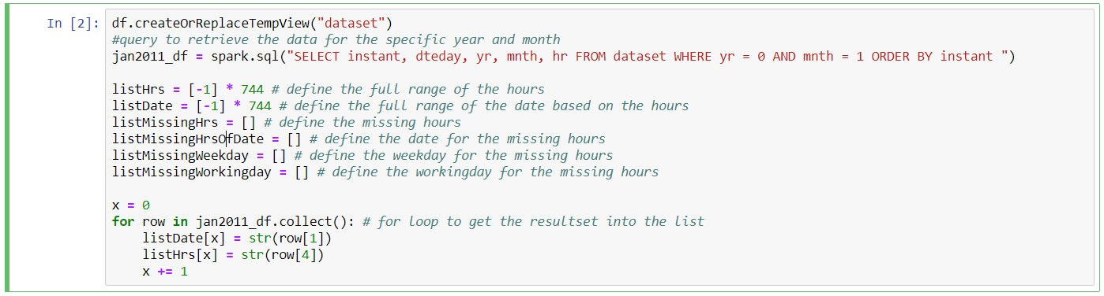

*Figure 24: Query Results and Assign*

After assign the results into variables, I will use the for-loop to produce the missing values. Also, during producing the missing values, I am differentiating the weekday and workingday values by using Python library of datetime, because datetime is especially handling all kinds of datetime issues and formats (*Figure 25*).

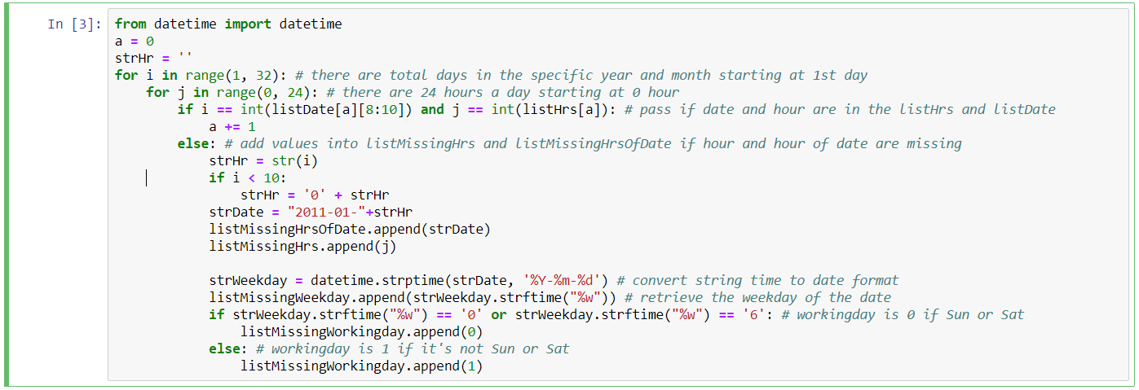

*Figure 25: Store Missing Values and Handle Datetime Values*

Furthermore, after producing the missing values, I then insert these missing values back into the CSV file (*Figure 26*). To note that, I put instant as 0, and I will re-order the sequence for all data later. So, this 0 is just to do the filter easier later because the existing ones have from 1 to 17379.

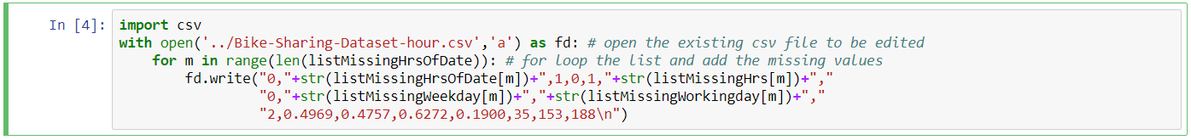

*Figure 26: Insert Missing Values in CSV File*

Also, I put 1 for season as January is in first quarter. We know that yr is 0, mnth is 1. Holiday is 0 that means not a holiday, because there are only 165 missing values that won’t really seriously affect the entire data even though the day is actual holiday. Weathersit is just taken the mean value that is 2.

For temp, atemp, hum windspeed, casual, registered and cnt, I have already got the averages earlier in this section, and I take only 4 decimal places of the values instead of all decimal places. Run the entire script, the missing values will be appended at the end of the CSV file.

Last but not least, I do a full query check to confirm the missing values if they have been added. First to check the total counts then secondly query the entire January 2011 data (*Figure 27*). As we can see, the total results are 744 which mean that there are 744 hours in January 2011. Hence, the insertion is correctly done.

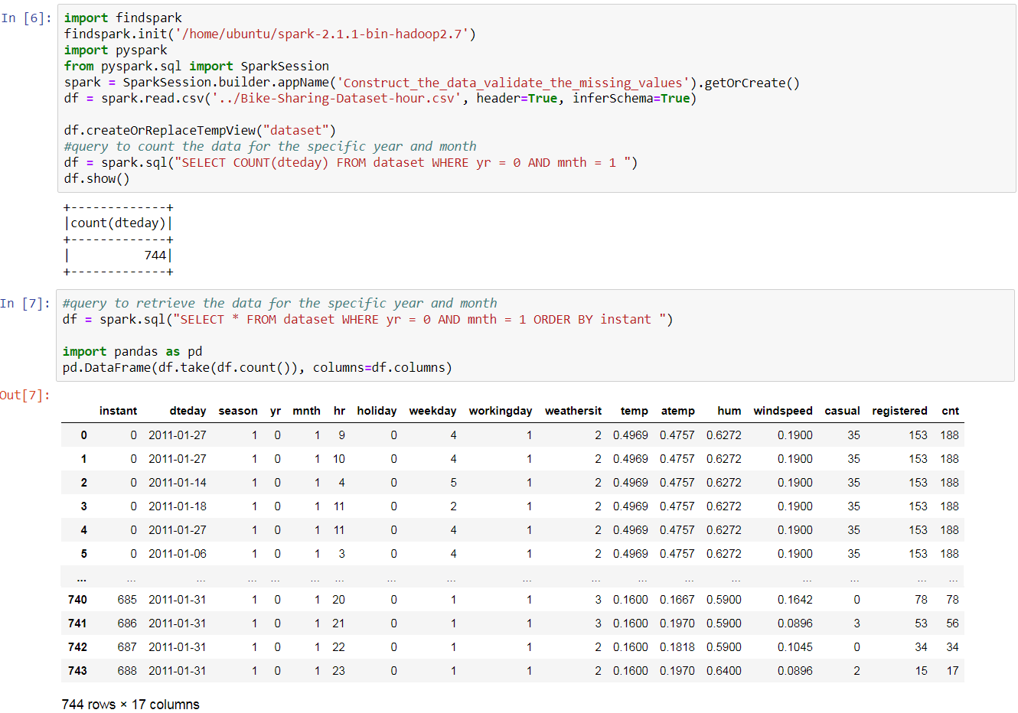

*Figure 27: Validate the Missing Values*

I then continue to insert the missing values for the rest of years and months, and will skip the writing for those repeated steps. As I mentioned, please find those scripts to generate the rest missing values under folder Construct_the_data. Finally, I do the entire data check (*Figure 28*). The total number is 17544 which represents all hours from 2011 to 2012 correctly.

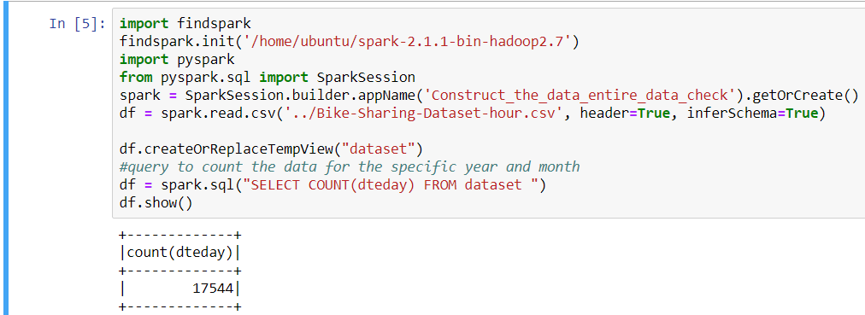

*Figure 28: The Complete Data Set*

3.4 Integrate various data sources

Now, I am going to re-order the sequence for all the data. To start with, I need to create a new column that is called reinstant (*Figure 29*). Then I put all existing data into a new CSV file with new column reinstant – *new CSV file is Bike-Sharing-Dataset-hour_new.csv*. It may be realized that x is the index counter increasing =+1 each time for the new column reinstant, so that it could have the correct sequence for all the data.

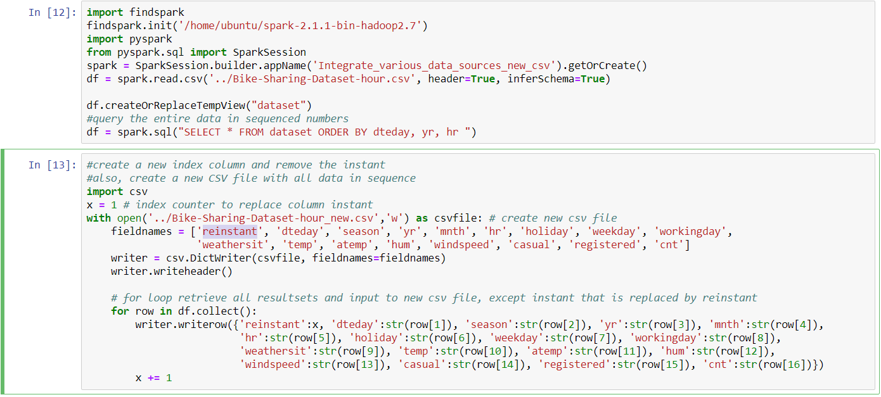

*Figure 29: New CSV with New Column reinstant*

Now, we can see the reinstant column has exact 17544 data and it is in sequence correctly (*Figure 30*). We can now start using column reinstant instead of column instant.

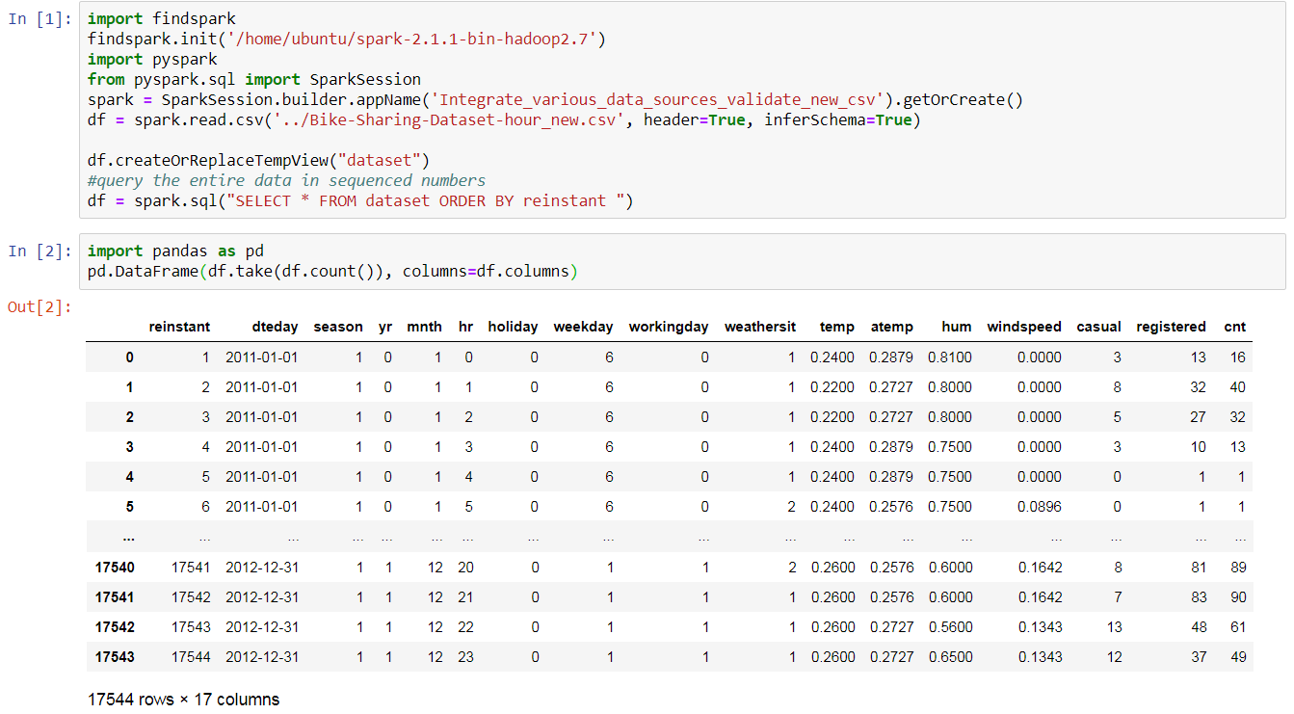

*Figure 30: Validate the Entire Data Set*

3.5 Format the data

In this step, I am going to check the data types of the new CSV file. If there is any type of the field that is not correct, I will format it. Use the following scripts to retrieve all field types (*Figure 31*). We can see that fields are mostly integers. Four of them, temp, atemp, hum and windspeed are doubles. Dteday is timestamp. Also, all of them allow nullable inputs.

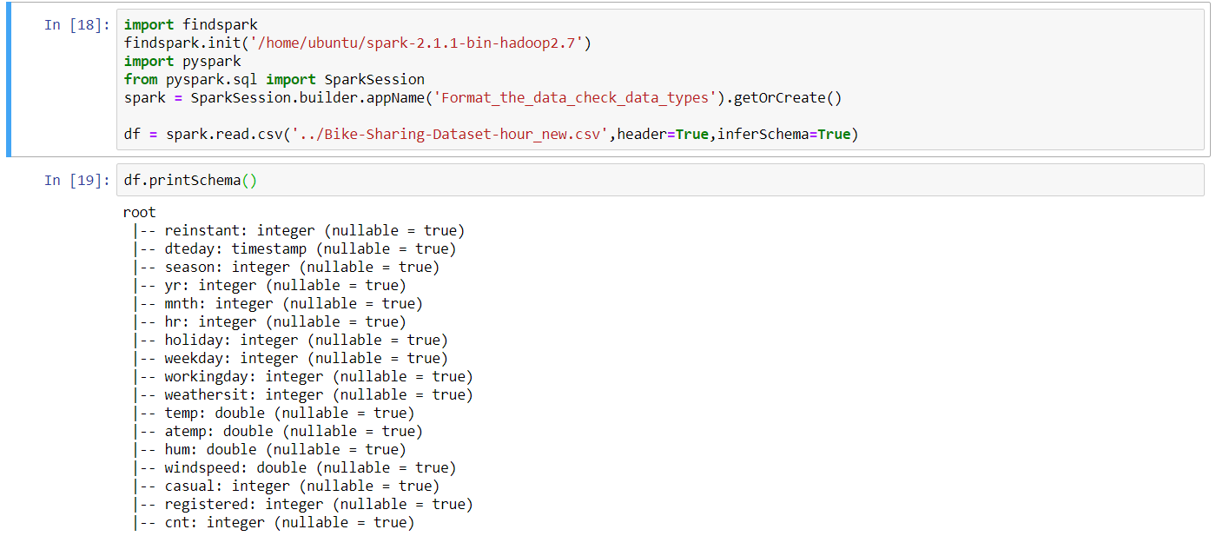

*Figure 31: Retrieve All Data Types*

In order to check more details of the data and confirm the formats are correct, I am going to do some combination checks and assessments, such as get the mean and standard deviation, filter the numbers, search the date and time, because integers could be calculated by using “+, -, *, /” and filter method, whereas string couldn’t. If the field’s format is not correct, there should be an error thrown. The following checks are proved that all data formats are correct (*Figure 32*). Therefore, there is no further data format required, and I conclude that all data types are correct. *Please refer to ‘Format the data - check more data format.ipynb’ for more detail checks.*

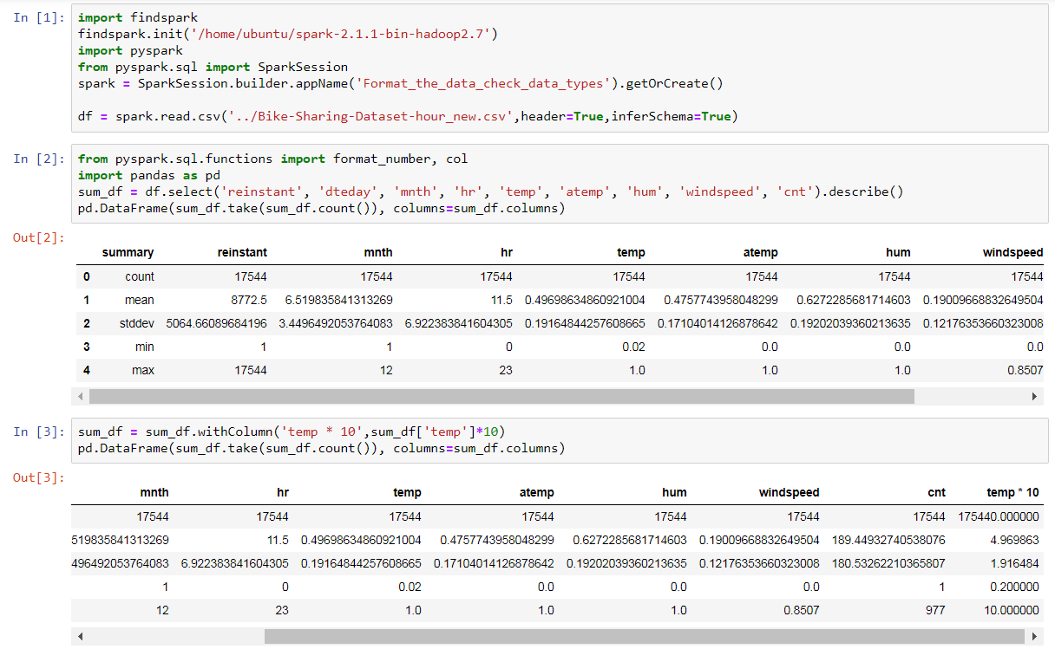

*Figure 32: Combination Checks for Data Format*

**4. Data Transformation:**

4.1 Reduce the data

In this step, let’s discuss if some data need to be removed or retained. I now group the season against the casual, registered and cnt (*Figure 33*) and produce the bar chart for seasonal counts (*Figure 34*). It indicates that more people use the bike sharing services in spring and summer than in autumn and winter.

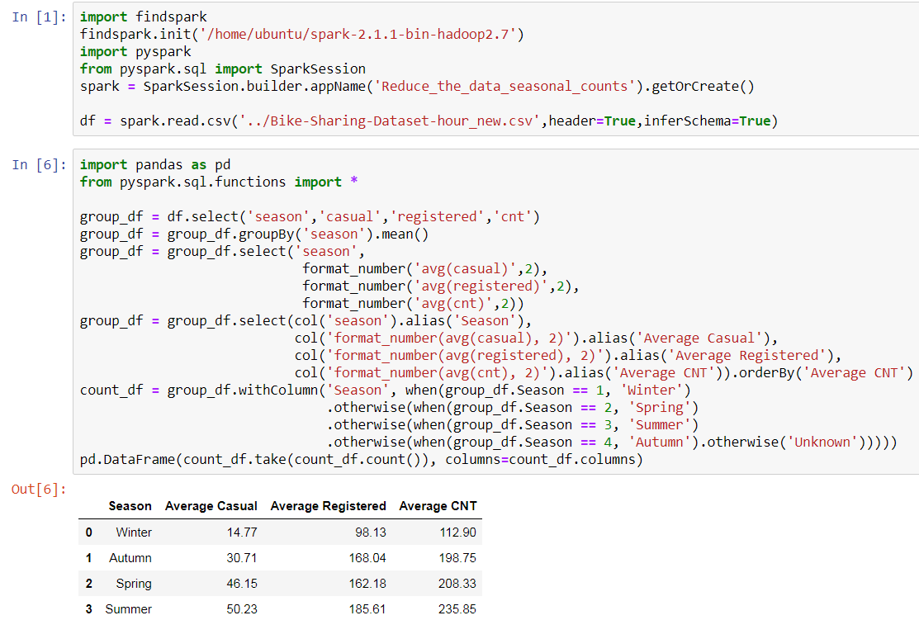

*Figure 33: season against casual, registered and cnt*

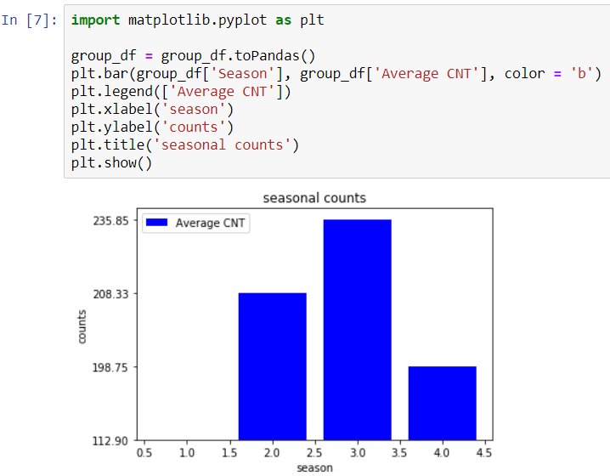

*Figure 34: Bar Chart of Seasonal Counts*

Again, I try to group the mnth against the casual, registered and cnt, which has similar counts during the seasonal periods (*Figure 35*) and similar patterns from the graph (*Figure 36*). For example, Dec to Mar have the small amounts, which is in cold weather (winter and autumn); whereas around Jun to Sep have the most counts, which is in warm weather (spring and summer). Compare between the seasonal and monthly counts, I find that I can get more details from monthly counts. Hence, I may just use mnth data rather than season, because using mnth data has more specified details as 12 months versus to 4 seasons.

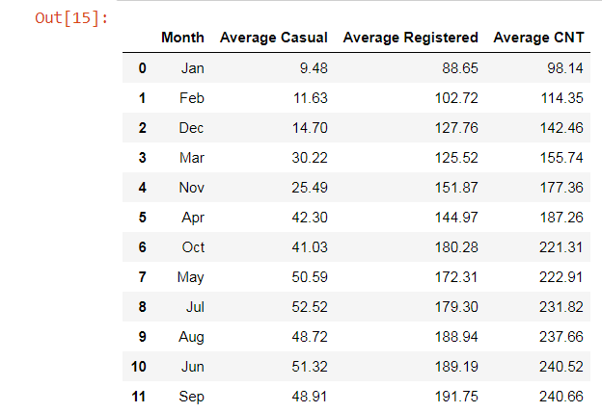

*Figure 35: mnth against casual, registered and cnt*

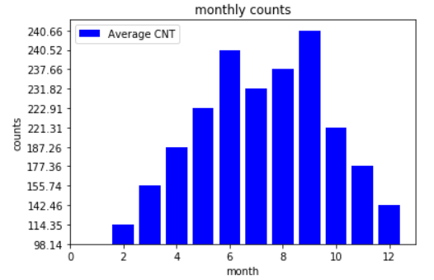

*Figure 36: Bar Chart of Monthly Counts*

In addition, I get the average of casual, registered and cnt to versus hr (*Figure 37*). I could see much more details now as it illustrates that during the peak hours, bike sharing services are occupied much more than the off-peak hours. There two peak hours in a day, the afternoon peak hours are more significant than the morning peak hours.

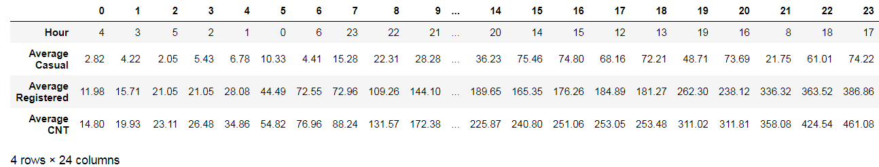

*Figure 37: hr against casual, registered and cnt*

Produce the hourly counts graph as follows (*Figure 38*). It’s interesting that even in a daily basis, it has the similar patterns as shown in seasonal and monthly graphs. Most importantly, using the hourly counts, which I could get even more details and vivid vision of the patterns.

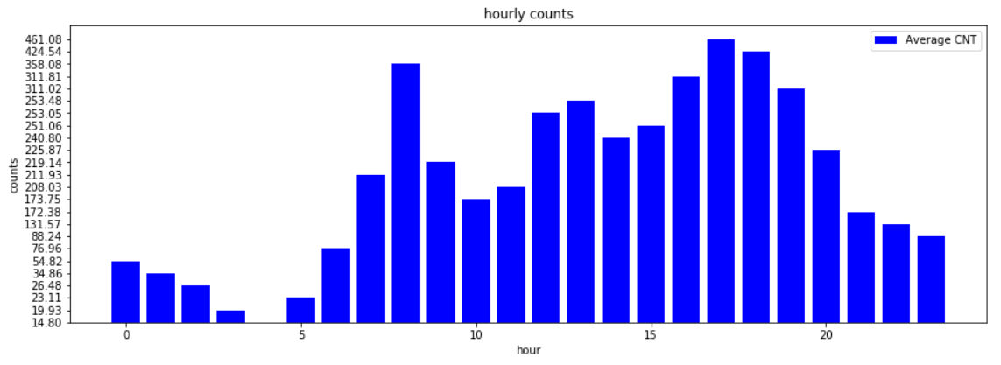

*Figure 38: Bar Chart of Hourly Counts*

Also, as known, cnt is the summation of casual and registered. So, I plot the cnt only to versus dteday – *I use reinstant instead of dteday here because reinstant represents dteday as in time series and easier for calculation* (*Figure 39*). I can see much clearer details from this graph. The graph interprets that more people use the services during May to Oct than other months. The counts have the lowest around the Dec and Jan. It is with the highest counts in the middle of the year around May to Oct. Then it starts decreasing and ends at Dec. It seems to be a usual pattern for bike sharing business, because this pattern applies to two consecutive years. The important thing is predictable that the trend is going up. It may be expected it will get more users in the following years after 2012.

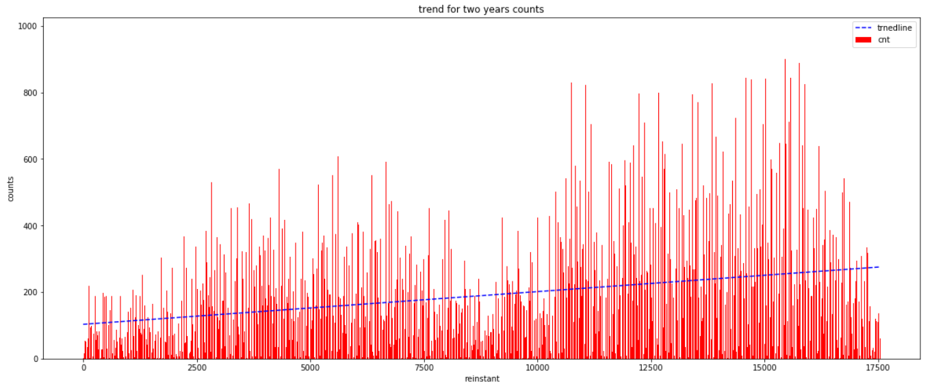

*Figure 39: The Trend Line and cnt V.S. reinstant*

Furthermore, I try to plot the weekday towards casual, registered and cnt (*Figure 40*). Throughout Monday to Sunday, there isn’t many difference on the total cnt. However, on Sunday and Saturday, registered users are declined as comparing to weekdays; whereas, casual users have more on weekends rather than weekdays. The reason behind is probably because weekends’ public transports are limited rather than on weekdays. Registered users are mostly using bike for the commute on weekdays. On the other hand, casual users are using bike for casual purpose on weekends. Therefore, summing up registered and casual users, which balance off the weekends and weekdays users as in total cnt.

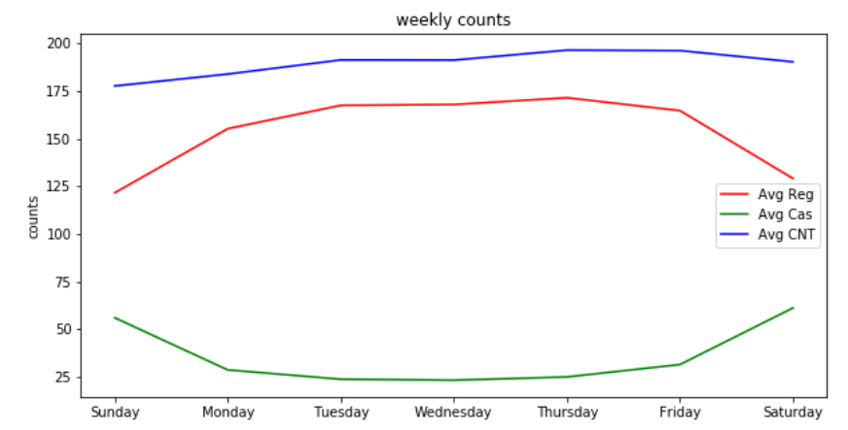

*Figure 40: casual, registered and cnt V.S. weekday*

Also, I try to put holiday on the left and workingday on the right against casual, registered and cnt separately (*Figure 41*). Interestingly, it seems that non-holiday has just a little bit more than holiday on average; whereas, workingday is more than non-workingday. The gap between workingday and non-workingday is smaller than holiday and non-holiday.

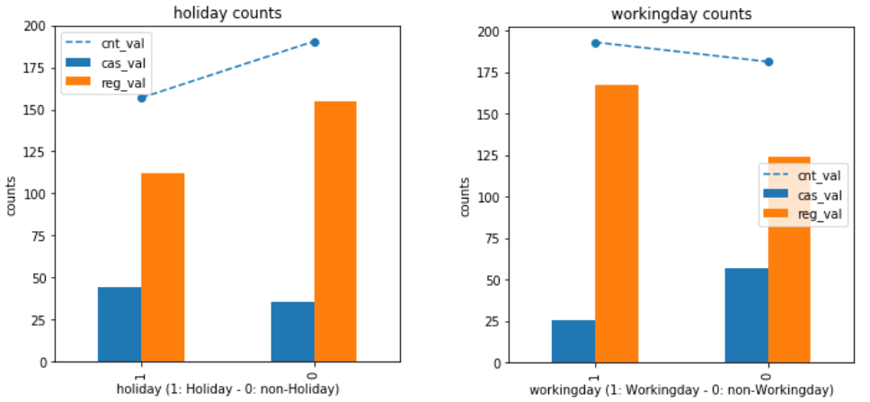

*Figure 41: casual, registered and cnt V.S. workingday and holiday*

For the time series data, I will not utilize season field as it has already reflected in the mnth field. To note that, yr is included in dteday. So, yr will not be used either. Also, we know that the total cnt is summed by casual and registered. I will then utilize the cnt only, and leave casual and registered. Although registered and casual have differences on weekdays and weekends, for the business perspective, it will be more reliable on the total cnt. Hence, cnt will be sufficient for the further processes.

Now, let’s look at the environmental factors. Firstly, I plot the temp and atemp against cnt (*Figure 42*). I am thinking of there should be more people using bike in warm temperature but not in the both extremes. However, in the temp graph on the left, there are increases till 0.85, and decreases dispersing closed between 0.95 and 1; whereas in atemp, between 0.6 to 0.9, the volumes remain high, which interpret that it’s in high demand for bike.

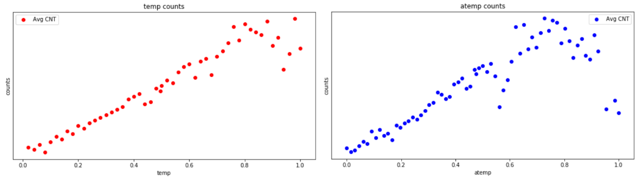

*Figure 42: cnt V.S. temp and atemp*

Then, I plot the hum and windspeed against the cnt (*Figure 43*). As we can see, start from 0.2, the hum has most of users and declines afterward; whereas in windspeed, it has stable increases till around 0.4, but after that, it has huge sudden drops. It probably has a strong windspeed, which prevent people from using bike. However, slow windspeed should have increased even more people to use bike services, which do not apply in this situation because there is less count from 0 to 0.2 rather than 0.4. Therefore, it might be associated with some other events and factors in those unusual areas.

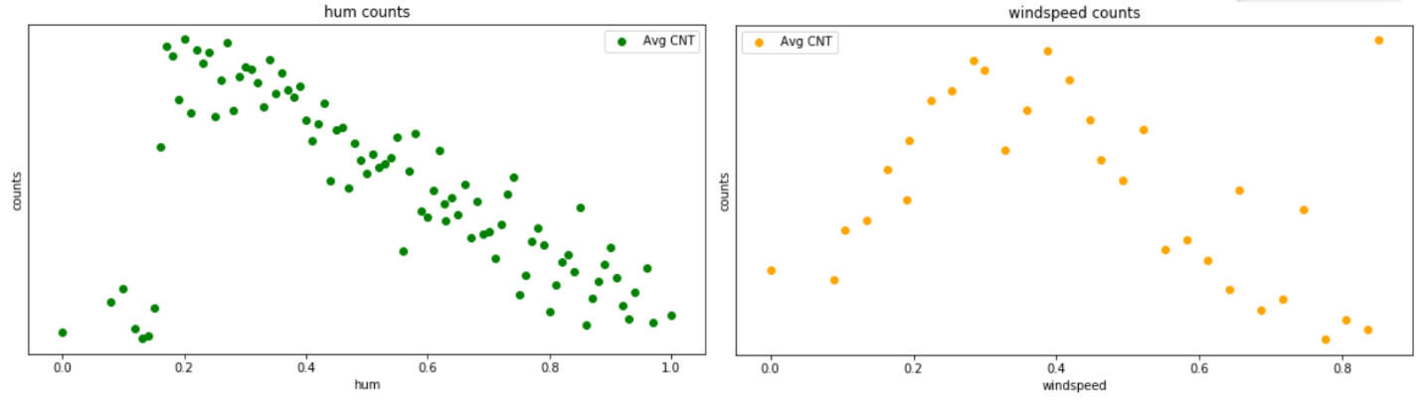

*Figure 43: cnt V.S. hum and windspeed*

Admittedly, when I plot the weathersit against the cnt (*Figure 44*), the counts are less while weathersit is bigger. This is because extremely bad weather prevents people from using the bike. Hence, weathersit is one of the important fields to take into account. For the environmental series data, weathersit should be definitely taken into consideration, and I will also put temp, atemp, hum and windspeed for further assessments. For other fields, such as instant (has been removed), casual, registered, mnth, season and yr, I will exclude them for the further assessments.

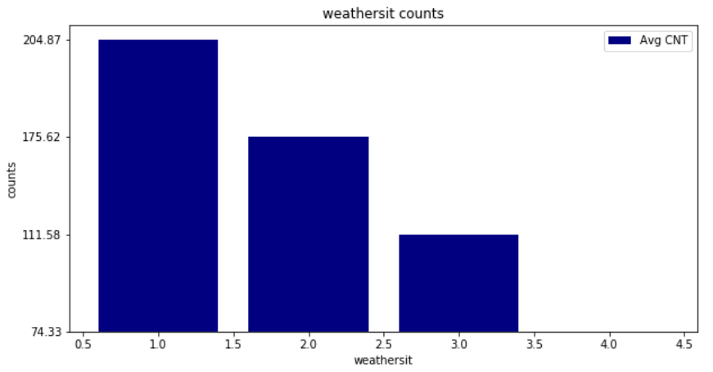

*Figure 44: cnt V.S. weathersit*

4.2 Project the data

In this step, first of all I will retrieve the statistic information for all selected fields (*Figure 45*). All selected fields seem to be good, there is no abnormalities in the data, because if it has unusual data, I probably couldn’t produce the histograms or logarithms graphs for them.

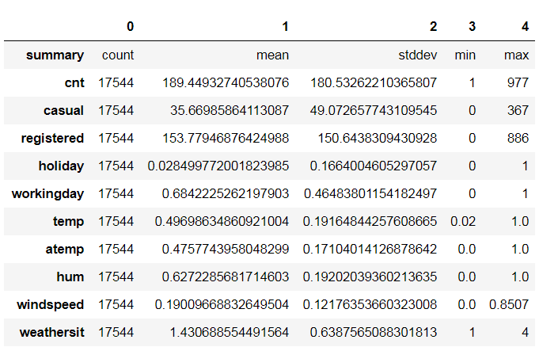

*Figure 45: Statistic Information of Selected Fields*

Since I have the hourly data set, I would not need to transform the dteday filed and extract it into hour, day of week and month again. This is the reason why in the very beginning of the data selection process I choose to use hourly data set rather than the daily data set. In addition, I have done quite a bit work on section 3, where I use scripts to extract, include, format and transform the data into better organized and readable dataset.

The following I will create histograms and logarithms for the selected fields one by one. Histogram of cnt is right skewed (*Figure 46*).

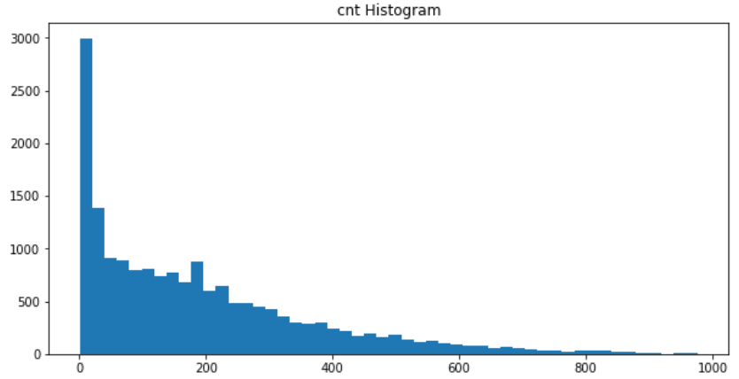

*Figure 46: Histogram of cnt*

Histogram of temp is multimodal (*Figure 47*).

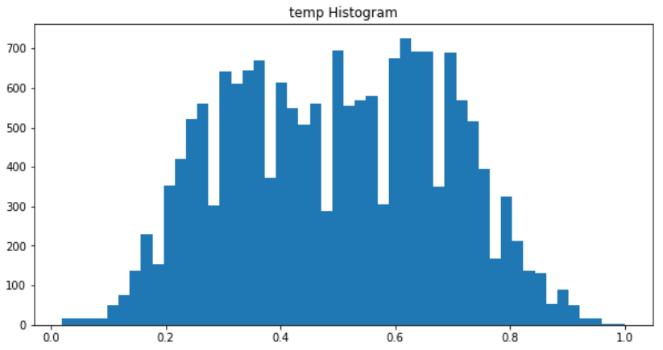

*Figure 47: Histogram of temp*

Histogram of atemp is also multimodal (*Figure 48*)

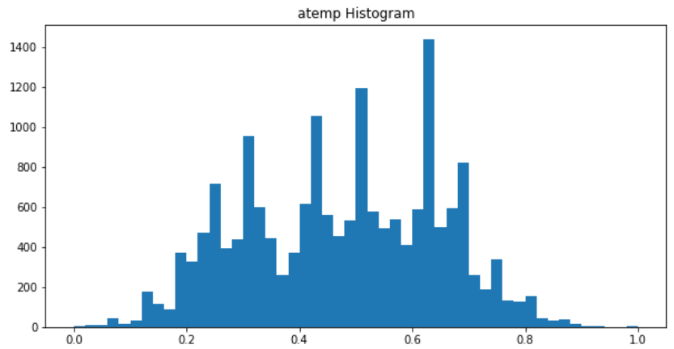

*Figure 48: Histogram of atemp*

Histogram of hum is multimodal as well (*Figure 49*)

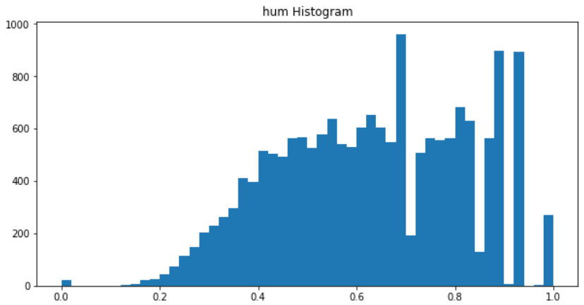

*Figure 49: Histogram of hum*

Histogram of windspeed that has unimodal though but seems to be not quite symmetric (Figure 50).

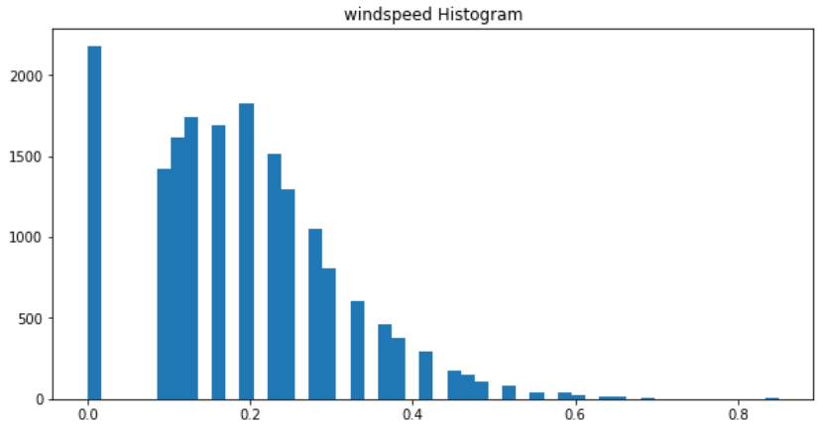

*Figure 50: Histogram of windspeed*

Next I am going to create logarithms. The cnt is getting symmetric unimodal but still got a long tail on the left (*Figure 51*).

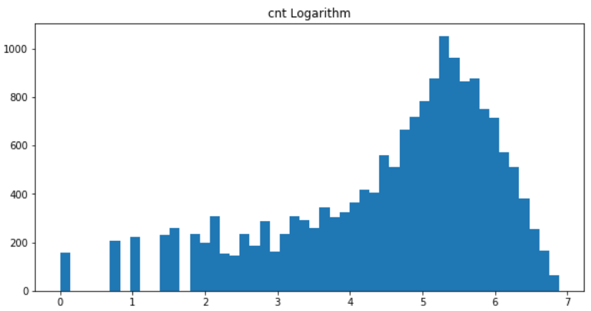

*Figure 51: Logarithm of cnt*

Logarithm of temp is bimodal but with skewed left (*Figure 52*).

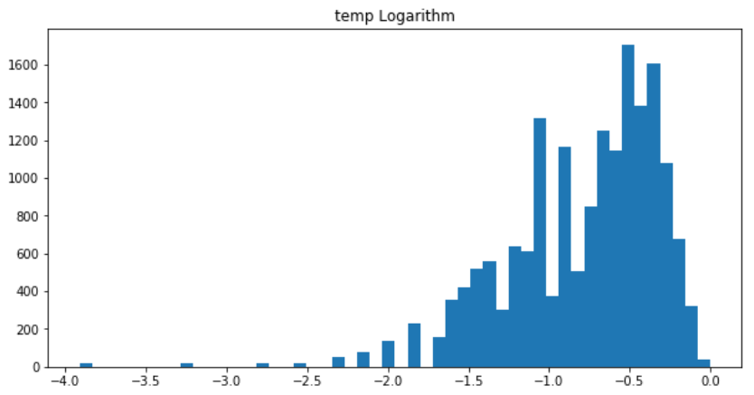

*Figure 52: Logarithm of temp*

Logarithm of atemp is unimodal but with skewed left (*Figure 53*).

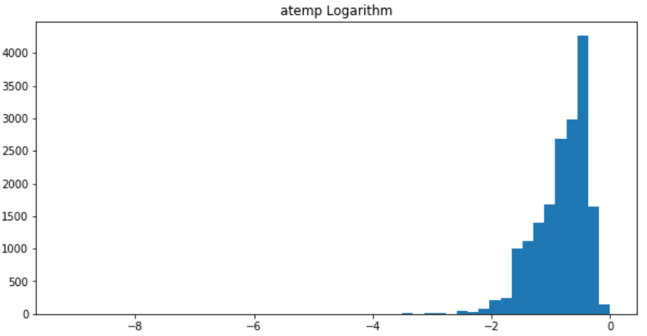

*Figure 53: Logarithm of atemp*

It seems that logarithm of hum is unimodal with skewed left too (*Figure 54*).

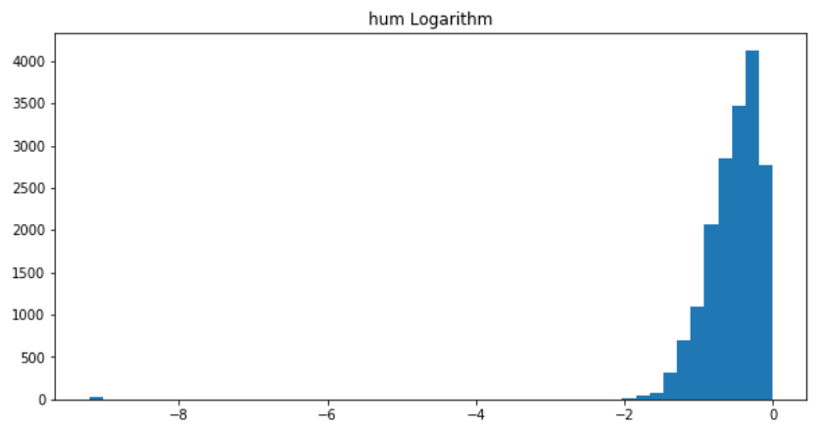

*Figure 54: Logarithm of hum*

Logarithm of windspeed seems to be unusual with an extreme value unfrequently distributing on the left. Others are bimodal with skewed left (*Figure 55*).

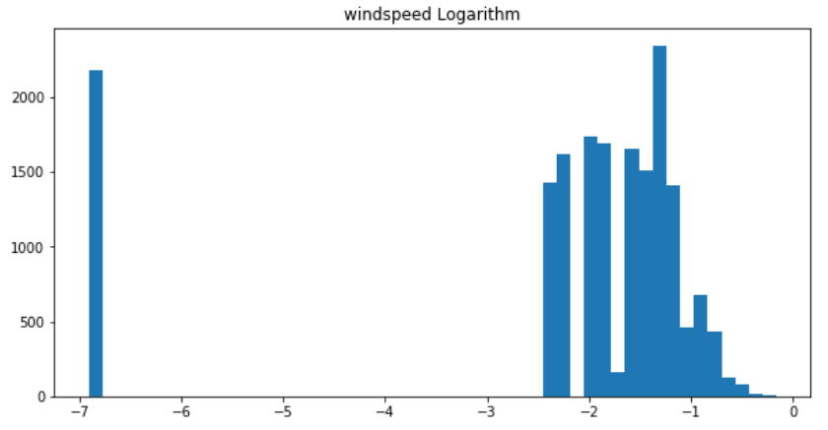

*Figure 55: Logarithm of windspeed*

**5. Data-mining method(s) selection:**

5.1 Match and discuss the objectives of data mining to data mining methods

As mentioned in the objectives of data mining earlier in this study, I am going to see the bike sharing total counts’ differences between weekday and weekend usage. Based on the weekday and weekend usage, I may see how the weekday and weekend factors affect the total count.

Borgnat et al. (2011) argued that weekdays show usage peaks in the morning, afternoon and late afternoon, whilst usage is concentrated in the afternoon on weekends. A statistical model for the prediction of the number on daily and hourly basis is better for the analysis.

Vogel et al. (2011) asserted that the recent research on bike sharing models either focus on mining of bike sharing data or building decision models without including the real world bike sharing behavior, such as ignoring the hourly fluctuations.

hr factor would be shown more details in this study rather than the data in daily basis. This is what I have always mentioned that the reason why I chose the data in hourly basis. I could probably see the differences between peak and off-peak usage during the day. Also, I will see the trend on holiday and workingday, because it implies the usage of bike sharing system on workingday and non-holiday.

As bike sharing grows as an important mode in urban transportation systems, shared bikes could find a significant niche in the transportation system. However, more studies with real-world data are required (Ji et al., 2014), for instance, the environmental issues which affect how people use the bike.

Environmental factors are also playing important parts on bike sharing systems as mentioned by the authors above. I will then include the environmental fields into the data mining processes, such as temp, atemp, windspeed, weathersit.

5.2 Select the appropriate data-mining method(s) based on discussion

Hearty and Gibney (2008) argued that supervised data mining methodology is used to model an output variable based on one or multiple input variables, and these models can be used to predict or forecast future cases.

Chen et al. (2016) analyzed that the supervised learning is used in dynamic link prediction method based on a model learnt from the variation of properties.

Therefore, based on the above discussion, I will then use supervised method on the data of weekday and weekend, peak usages, workingday and holiday, and all the environmental fields. Continuously, Jupyter will be the data mining tool for this study. Finally, based on the Jupyter learning results, I could predict the total counts much better in the coming years.

**6. Data-mining algorithm(s) selection:**

6.1 Conduct exploratory analysis and discuss

In this step, I will try to find the algorithms that suit to my data set. One of the studies employed spatial multiple linear regression analysis to examine the impact of built environmental variables on bike sharing trip demand (Zhang et al., 2017). They found that users prefer to choose a bike-friendly environment and more accessible to location where the bikes are easy to get.

Moreover, a large turnover generated nearby a residential community during weekends and off-peak hours of weekdays, and lower turnover and demand generated nearby a park during morning and evening peaks of weekdays.

According to above researchers’ saying, the case they studied is quite similar to mine. So, I am going to use the same algorithms that are *Linear Regression to* apply into my data set.

6.2 Select data-mining algorithms based on discussion

There are a number of supervised algorithms for data mining. To specific, linear regression that is supervised algorithm will be used in this study as discussed.

I will use *Linear Regression* in Jupyter. At the end, the results will be shown each field against the cnt with the respective statistics, and also the summary of the statistics for all fields as the whole model and algorithm.

Based on the statistics, I could tell how well or bad the models and algorithms are. Evaluation may be performed to those models and get much better understanding of them. Finally, I may get the best models for this study.

6.3 Build/Select appropriate model(s) and choose relevant parameter(s)

In Jupyter, I will use supervised regression models for the data set. As discussed in 4 and 5, I will only use 12 fields for further data mining but not the whole dataset, namely, reinstant, hr, mnth, weekday, holiday, workingday, temp, atemp, hum, windspeed, weathersit, and cnt.

The reason why I drop dteday is because reinstant indeed represents dteday in sequence. By using reinstant, it could be easier for the calculation. yr is only showing 0 and 1 which represent the 2011 and 2012. season is already involved in mnth. The sum of casual and registered is the cnt. So, I just put away these 5 fields from my entire dataset for the linear regression.

Now, I can build the model directly by using the latest dataset. Firstly, I get the summaries for all these selected fields (*Figure 56*).

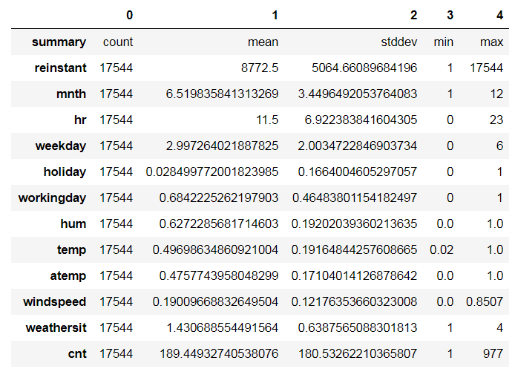

*Figure 56: Summaries of Selected Fields*

Secondly, I create a vector features with data from each field except cnt, and show the first line record (*Figure 57*).

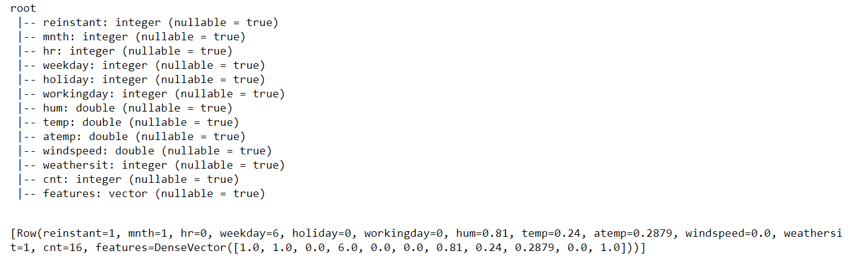

*Figure 57: Vector with Data from Each Field*

Then I organize the features and cnt into a table format (*Figure 58*).

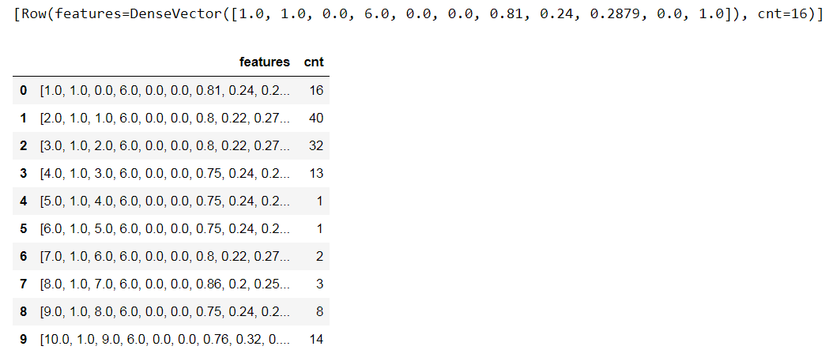

*Figure 58: Organize the Data into a Table*

Again, I get the summaries for features and cnt. Only cnt is shown (*Figure 59*).

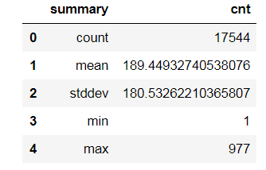

*Figure 59: Summaries of cnt*

Lastly, I plot the linear regression for my data (*Figure 60*). However, I can see that the results aren’t good. R2 has only 38% of the variability in cnt. I will improve it in next section.

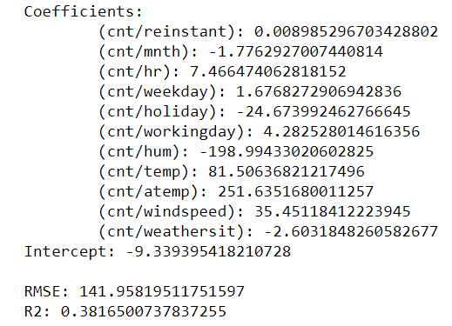

*Figure 60: Build the Linear Regression Model*

**7. Data Mining:**

7.1 Create and justify test designs

In this step, I will split the entire data into two parts that are training and testing data sets. The ratio of them is 80% (training):20% (testing). The total records are 17544, so there are about 14000 records for training and 3500 records for testing, which should be sufficient for the models in this study.

Rajer-Kanduc, Zupan, and Majcen (2003) illustrated that the data set should be divided into the training and testing data sets in order to apply most of the standard chemometric modelling methods. The training sets and the modelling method are paramount important, whereas the testing sets are inevitable for evaluation of model’s characteristics.

The following section I will use Jupyter to create training data and testing data. First I will use training data to run the linear regression model. Then I will use testing data to evaluate the lienar regression model.

7.2 Conduct data mining – classify, regress, cluster, etc. (models must execute)

I am going to conduct data mining in this step. Prior to this step, I’ve built the model with entire dataset and got *Correlation coefficient* between cnt and each of the field. However, I will use training data and testing data to improve it separately.

The steps to build linear regression are similar to 6.3 in Jupyter. But after organize the features and cnt into a table format, I put train_data and test_data with ratio of 0.8/0.2 into the vector (*Figure 61*).

As I can see, there are about 14155 counts for training data and 3389 for testing data. The mean for training is about 189 and stddev is about 179; whereas the mean for testing is 193 and stddev is 185, which are slightly bigger than training sets.

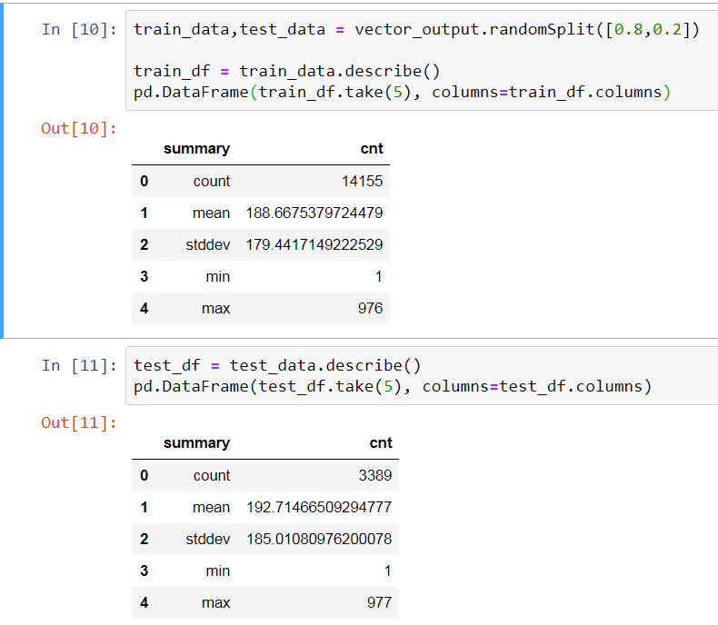

*Figure 61: Separate Training and Testing Data with Ratio 0.8/0.2*

Run the linear regression model with training dataset (*Figure 62*).

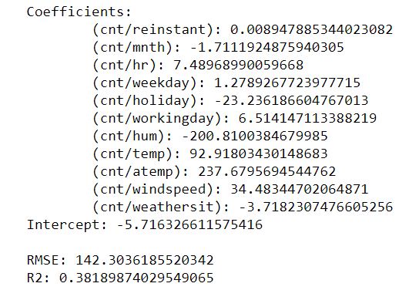

*Figure 62: Executable Linear Regression Model with Training Dataset*

Finally, I produce the residuals of the model below (*Figure 63*).

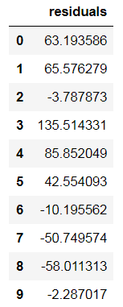

*Figure 63: Residuals of Linear Regression with Training Dataset*

7.3 Search for patterns

As we can see, the model now is slightly better than the previous one as in RMSE from 141.96 to 142.30 and R2 from 0.3817 to 0.3819. The model has a little improvement.

Also, look at the cnt/mnth with -1.7, it illustrates that month has negative coefficient, which expect the month to decrease about 1.7 when cnt increases by 1; whereas hr is to increase 7.5; weekday is to increase 1.3; workingday is to increase 6.5; weathersit is to decrease 3.7. These variables are to increase or decrease with small numbers, but for holiday, hum, temp, atemp and windspeed, they need to increase or decrease with much bigger numbers.

The intercept is -5.7, which interpret that when x-axis is 0, y-axis is -5.7. As for the bike sharing services, it has seasonal effects under a time series. Also, the trend of the bike sharing services I have illustrated above sections, it is going upwards stably. Hence, it will be always a small number of users in the beginning of the services, but the users will eventually increase slowly with seasonal effects.

**8. Interpretation:**

8.1 Study and discuss the mined patterns

What we can see from the above patterns are getting improved and a little better*.* The coefficient numbers indicate that it has positive or negative correlation and for every positive or negative increase in one variable, there is a positive or negative increase of a fixed proportion in the other. The numbers are closer to 1, the greater relations they have.

The next important numbers I am looking at are the *RMSE and R2.* RMSE suggests that a fit to the data. The lower RMSE is better than a higher one. However, comparisons across different types of data would be invalid because the measure depends on the scale of the numbers used. The RMSE that I got is 142.30, which definitely has much more room to improve. I will look into it later.

R2 values range from 0 to 1 and are commonly stated as percentages from 0% to 100%. The higher R2 is the better one that means all movements of a dependent variable are completely explained by movements in the independent variable. I got 0.38 for the R2, which would should have a better improvement as well.

Last but not least, residuals numbers illustrate that a residual plot are randomly dispersed around the horizontal axis, a linear regression model is appropriate for the data; otherwise, a non-linear model is more appropriate. The table above *Figure 63* shows that the numbers are dispersed around the 0 number, which strongly suggest the linear regression model is good fit for the data. Just that, there are much more room to improve the model.

8.2 Visualize the data, results, models, and patterns.

In Visualize_the_data folder, I generate the following graphs for all variables (*Figure 64*). These graphs give summaries of the relationships among all selected variables. The limitation here is that I couldn’t click on individual graph and zoom into it. Instead, I could produce them individually, but that won’t be necessary to produce all of them. Selectively, I will produce those important ones.

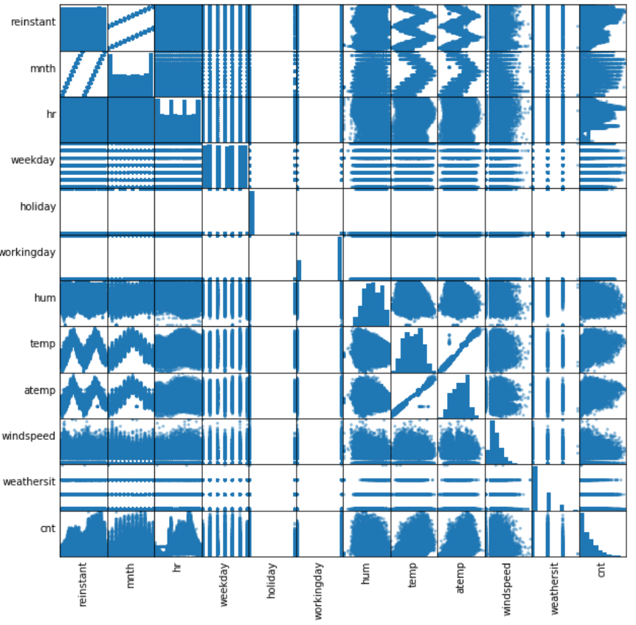

*Figure 64: Visualize All Variables in Summary*

Residuals of linear regression histogram (*Figure 65*)

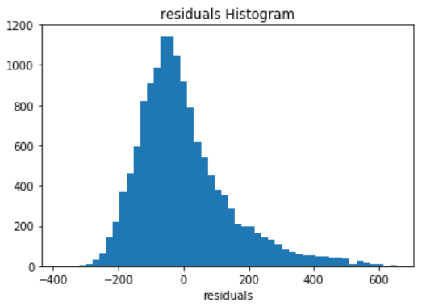

*Figure 65: Residuals Histogram of Linear Regression with Training Dataset*

8.3 Interpret the results, models, and patterns

The graph above *Figure 65* shows that the residuals are dispersed around the 0, which strongly suggest the linear regression model is good fit for the data once again. The histogram is standard distributed and results seem to be pretty good.

As analyzed, I can find that the bike sharing services have seasonal effects (*Figure 66*). At the beginning of this study, I have already mentioned that seasons in winter and autumn have less counts than seasons in summer and spring, which interpret that people probably don’t want to use the bike in the cold weather rather than the warm weather. We can see the graphs are in upward trend then going downward after around autumn/Sep/18pm respectively from the graphs.

In the hourly graph daily basis, I can see more details that a curve interprets the morning and afternoon peak hours. The morning and afternoon peak hours are the two important duration for bike sharing services. However, in the beginning of the day, it has slightly high volumes around mid-night, dropping till 4am. Then it starts to go up.

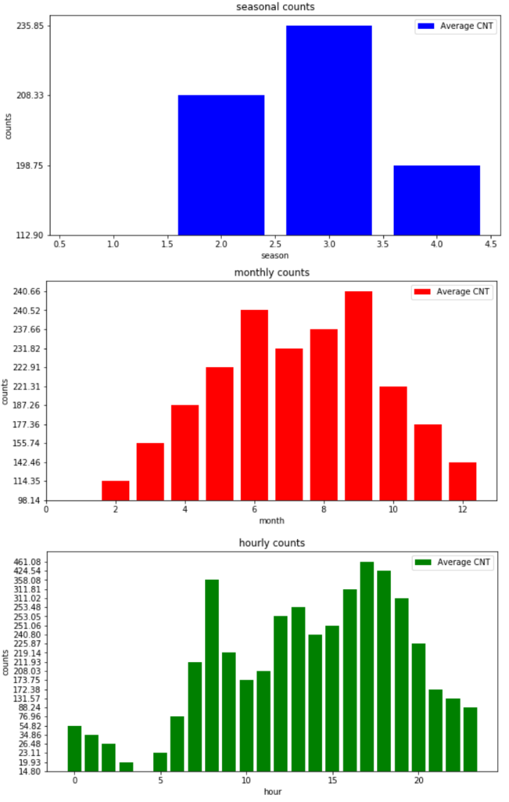

*Figure 66: Seasonal Effects of Bike Sharing Services*

Besides, the temp, atemp, weathersit, windspeed are also affects the bike sharing services to some extent (*Figure 67*), especially team and atemp. They seem to be quite reasonable, because they go up and cnt goes up, until certain points the cnt stops and decreases; whereas hum and windspeed drop down in some middle points.

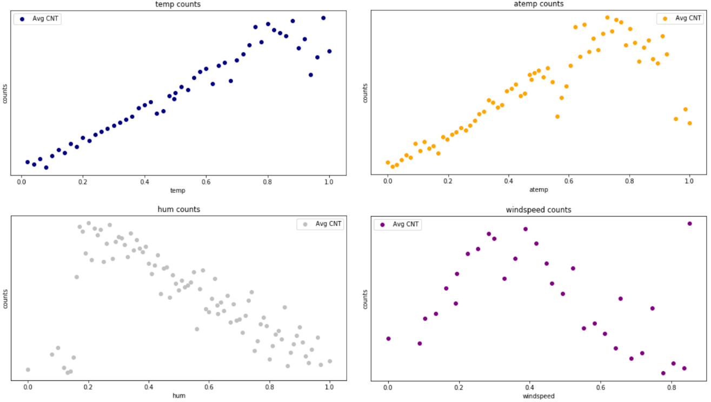

*Figure 67: Weather Issues for Bike Sharing Services*

8.4 Assess and evaluate results, models, and patterns.

Evaluate the model with testing dataset under folder Evaluate_the_model. I got results as follows (*Figure 68*). I can see the results are similar to the training ones, but it just has a little better results. I will iterate previous steps to improve the model next.

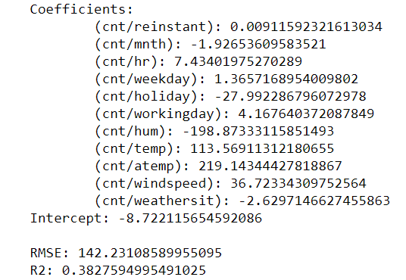

*Figure 68: Executable Linear Regression Model with Testing Dataset*

8.5 Iterate prior steps (1 – 7) as required

I am going to create a linear regression model with lag1. To begin with, type the following codes (*Figure 69*). As you may see that, “LAG(cnt,1,0) OVER (ORDER BY dteday, yr, hr)” is to create the lag values of cnt and “ORDER BY” is the same as the entire select * values. Then, run it to create a new csv file “Bike-Sharing-Dataset-hour_lag1.csv”.

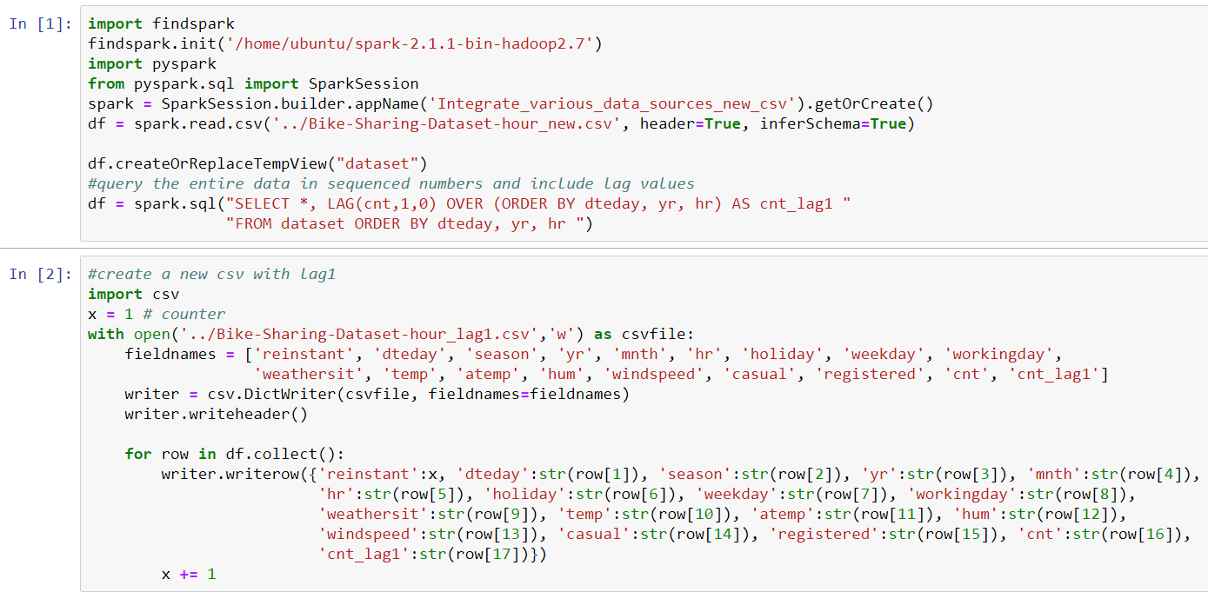

*Figure 69: Create a New CSV File with Lag Values*

After create the new CSV file, validate its types (*Figure 70*). It is created correctly.

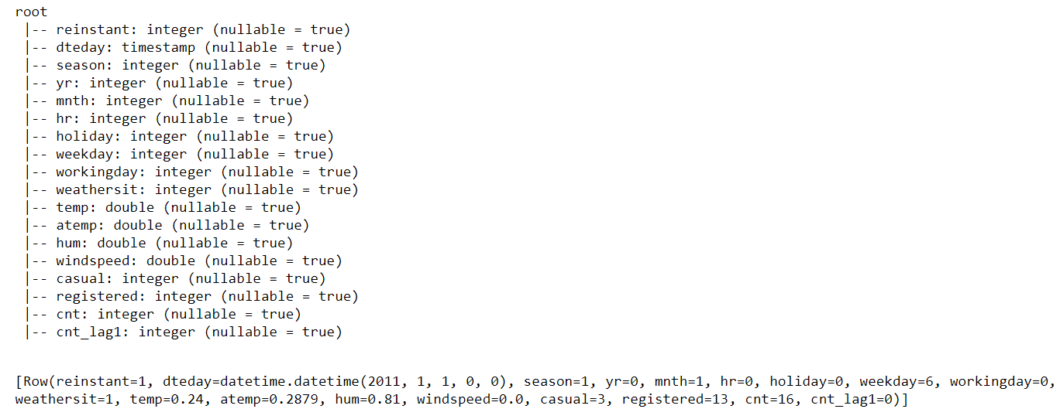

*Figure 70: Validate the New CSV File Types*

In addition, validate its columns and rows, especially to check cnt_lag1 column (*Figure 71*). As we can see, first row cnt is 16 and cnt_lag1 is 0, second row cnt is 40 and cnt_lag1 is 16, until the last two rows cnt is 61 and 49, and cnt_lag1 is 90 and 61, which conclude that the lag1 is created successfully.

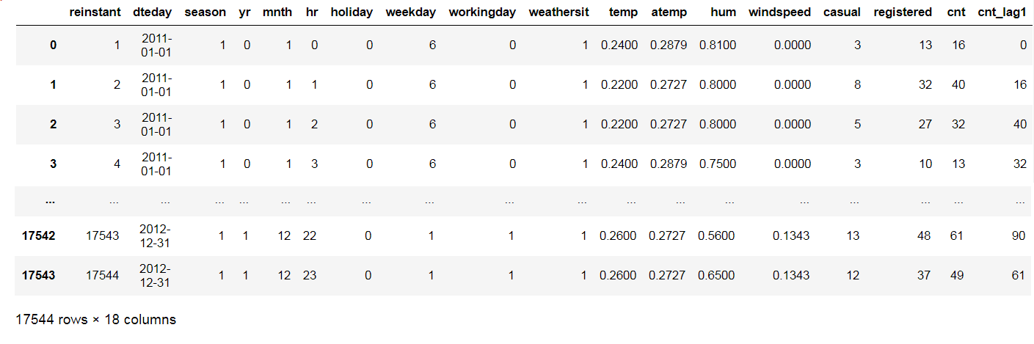

*Figure 71: Validate the New CSV File*

Now, I can continue the linear regression model with lag1. I got a greater improvement below (*Figure 72*). The RMSE is getting smaller which is good; whereas R2 is 43% as compared to previous 38%, which is also a better result.

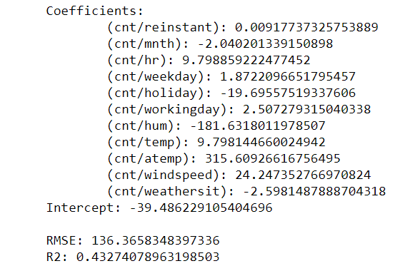

*Figure 72: Improvement of Linear Regression Model with Training Data and Lag1*

Let’s look at the testing data below (*Figure 73*), which is getting much better too. RMSE is 134 and R2 is 43% as compared to previous 142 and 38% respectively.

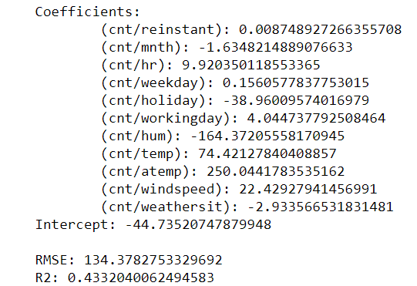

*Figure 73: Improvement of Linear Regression Model with Testing Data and Lag1*

**9. Action:**

9.1 Discuss how you would apply the knowledge and deploy the implementation

The selected fields I use above for the models are incorporated the *Linear Regression* model. All these fields are important, but only few can be ignored. Therefore, I will pay a significant attention to those important ones. For example, in peak hours, weekday and workinday, increasing and putting more bikes in the city area in case of bike shortage, which will be added huge benefit for the business. For casual usages, it is better to allocate the bikes near the neighbor and communities, and the public event area, such as parks, zoos, stadiums, and large playgrounds. This could possibly help people get awareness of the bike sharing services.

Additionally, prices award for registered users rather than casual users, which may encourage more casual users to register the services. Eventually, people will stick on the services and utilize the services even more.

9.2 Discuss how you would monitor the implementation

Occasionally, sending survey and having interview with the users at the docking stations. It is possible that monitoring people’s activities by installing CCTV at the docking station, which could capture how and when people use the services.

Alternatively, send survey via the internet systems, in particular the mobile app. Enforce people use the services through the mobile app, which means that people must use mobile to book and pay for the systems in order to use the bike sharing services.

Also, plant smart card technology to the bike sharing systems, which generate station-based data or trip-level data and facilitates studies of the practical use of bike sharing systems, as well as uncovers the spatial and temporal patterns of cycle trips (Zhang et al., 2016). This technology may discover the aspects of bike sharing services, such as distance of usage.

9.3 Discuss how you would maintain the implementation

Collect the data in periodical manner, then the data can be deployed to the model again. From there, we can see if the model is still fit. Adjustment needs to be made accordingly to the model and the bike sharing services. For example, as discussed, in winter people may use the services less because of the cold weather and perhaps people dress more clothes that make the cycling activities much more difficult. Hence, bike could be amended to have more space and easier to ride. Reduce cost to motivate people, as well as provide gloves to have cold protection, etc.

9.4 How could you enhance the solution in the future?

To enhance the solution, I would like to have more fields to be added to the model. For example, in the beginning of this study, I have already mentioned that the distance is one of the important fields to decide whether people want to use the bike sharing services, because it is unlikely that people cycle for a long distance.

Moreover, docking station is another important field. For instance, if docking station is far away from the destination, people would not use the services. However, the nowadays bike sharing services can be parked anywhere. This implies a concern if the location is allowed to be parked and occupied by the bikes.

Finally, how easy and safe to use the bike sharing services, which include the physical usages, such as is the bike easy to be used, does the bike have any potential hazard that would hurt people. Also, it includes the system usages, such as is it easy to book and grab a bike, how to make payment. All this information needs to be put together so that I could make a thorough consideration and produce a much better model and solution.

**Bibliography:**

Borgnat, P., Abry, P., Flandrin, p., Robardet, C., Rouquier, J., & Fleury, E. (2011). Shared bicycles in a city: a signal processing and data analysis perspective, *Advances in Complex Systems, 14*(3), 415-438. Retrieved from doi:10.1142/S0219525911002950

Chen, K., Chen, Y., Li, Y., & Han, J. (2016). A supervised link prediction method for dynamic networks, *Journal of Intelligent & Fuzzy Systems, 31*, 291-299. Retrieved from doi:10.3233/IFS-162141

Fanaee-T, H., & Gama, J. (2013). Event labeling combining ensemble detectors and background knowledge, *Progress in Artificial Intelligence*, 1-15. Springer Berlin Heidelberg. Retrieved from doi:10.1007/s13748-013-0040-3

Hearty, A., & Gibney, M. (2008). Analysis of meal patterns with the use of supervised data mining techniques – artificial neural networks and decision trees, *The American Journal of Clinical Nutrition, 88*(6), 1632-1642. Retrieved from doi:doi.org/10.3945/ajcn.2008.26619

Ji, S., Cherry, C., Han, L., & Jordan, D. (2014). Electric bike sharing: simulation of user demand and system availability, *Journal of Cleaner Production, 85,* 250-257. Retrieved from doi:doi.org/10.1016/j.jclepro.2013.09.024

Matrai, T., & Toth, J. (2016). Comparative assessment of public bike sharing systems, *Transportation Research Procedia 14,* 2344-2351. Retrieved from doi: 10.1016/j.trpro.2016.05.261

O’Brien, O., Cheshire, J., & Batty, M. (2014). Mining bicycle sharing data for generating insights into sustainable transport systems, *Journal of Transport Geography 34,* 262-273. Retrieved from doi:doi.org/10.1016/j.jtrangeo.2013.06.007

Papantonopoulos, G., Takahashi, K., Bountis, T., & Loos, B. (2014). Artificial neural networks for the diagnosis of aggressive periodontitis trained by immunologic parameters, *PLoS ONE, 9*(3), 1-8. Retrieved from doi:doi.org/10.1371/journal.pone.0089757

Rajer-Kandoc, K., Zupan, J., & Majcen, N. (2003). Separation of data on the training and test set for modelling: a case study for modelling of five colour properties of a white pigment, *Chemometrics and Intelligent Laboratory Systems, 65*(2), 221-229. Retrieved from doi:doi.org/10.1016/S0169-7439(02)00110-7

Ricci, M. (2015). Bike sharing: A review of evidence on impacts and processes of implementation and operation, *Research in Transportation Business & Management* *15*, 28-38. Retrieved from doi:doi.org/10.1016/j.rtbm.2015.03.003

Vogel, P., Greiser, T., & Mattfeld, D. (2011). Understanding bike-sharing systems using data mining: exploring activity patterns, *Procedia Social and Behavioral Sciences, 20*, 514-523. Retrieved from doi:10.1016/j.sbspro.2011.08.058

Zhang, Y., Thomas, T., Brussel, M., & van Maarseveen, M. (2016). Expanding bicycle-sharing systems: lessons learnt from an analysis of usage, *PLoS ONE, 11*(12), 1-25. Retrieved from doi:doi.org/10.1371/journal.pone.0168604

Zhang, Y., Thomas, T., Brussel, M., & van Maarseveen, M. (2017). Exploring the impact of built environment factors on the use of public bikes at bike stations: case study in Zhongshan, China, *Journal of Transport Geography, 58,* 59-70. Retrieved from doi:doi.org/10.1016/j.jtrangeo.2016.11.014